BANKERS

* Banker's Algorithm #include <stdio.h> int main()

{

* + P0, P1, P2, P3, P4 are the Process names here

int n, m, i, j, k;

n = 5; // Number of processes

m = 3; // Number of resources

int alloc[5][3] = { { 0, 1, 0 }, // P0 // Allocation Matrix

{2,0,0},//P1

{3,0,2},//P2

{2,1,1},//P3

{0,0,2}};//P4

int max[5][3] = { { 7, 5, 3 }, // P0 // MAX Matrix

{3,2,2},//P1

{9,0,2},//P2

{2,2,2},//P3

{4,3,3}};//P4

int avail[3] = { 3, 3, 2 }; // Available Resources

int f[n], ans[n], ind = 0;

for (k = 0; k < n; k++) {

f[k] = 0;

}

int need[n][m];

for (i = 0; i < n; i++) {

for (j = 0; j < m; j++)

need[i][j] = max[i][j] - alloc[i][j];

}

int y = 0;

for (k = 0; k < 5; k++) {

for (i = 0; i < n; i++) {

if (f[i] == 0) {

int flag = 0;

for (j = 0; j < m; j++) {

if (need[i][j] > avail[j]){

flag = 1;

break;

}

}

if (flag == 0) {

ans[ind++] = i;

for (y = 0; y < m; y++)

avail[y] += alloc[i][y];

f[i] = 1;

}

}

}

}

printf("Following is the SAFE Sequence\n");

for (i = 0; i < n - 1; i++)

printf(" P%d ->", ans[i]);

printf(" P%d", ans[n - 1]);

return (0);

}

PAGE REPLACEMENT ALGORITHMS

FIFO

#include<stdio.h>

int main()

{

int i,j,n,a[50],frame[10],no,k,avail,count=0; printf(“\n ENTER THE NUMBER OF PAGES:\n”); scanf(“%d”,&n);

printf(“\n ENTER THE PAGE NUMBER :\n”);

for(i=1;i<=n;i++)

scanf(“%d”,&a[i]);

printf(“\n ENTER THE NUMBER OF FRAMES :”); scanf(“%d”,&no);

for(i=0;i<no;i++)

frame[i]= -1;

j=0;

printf(“\tref string\t page frames\n”);

for(i=1;i<=n;i++)

{

printf(“%d\t\t”,a[i]);

avail=0;

for(k=0;k<no;k++)

if(frame[k]==a[i])

avail=1;

if (avail==0)

{

frame[j]=a[i];

j=(j+1)%no;

count++;

for(k=0;k<no;k++)

printf(“%d\t”,frame[k]);

}

printf(“\n”);

}

printf(“Page Fault Is %d”,count);

return 0;

}

OPTIMAL

#include<stdio.h>

int main()

{

int no_of_frames, no_of_pages, frames[10], pages[30], temp[10], flag1, flag2, flag3, i, j, k, pos, max, faults = 0;

printf("Enter number of frames: ");

scanf("%d", &no_of_frames);

printf("Enter number of pages: ");

scanf("%d", &no_of_pages);

printf("Enter page reference string: ");

for(i = 0; i < no_of_pages; ++i){

scanf("%d", &pages[i]);

}

for(i = 0; i < no_of_frames; ++i){

frames[i] = -1;

}

for(i = 0; i < no_of_pages; ++i){

flag1 = flag2 = 0;

for(j = 0; j < no_of_frames; ++j){

if(frames[j] == pages[i]){

flag1 = flag2 = 1;

break;

}

}

if(flag1 == 0){

for(j = 0; j < no_of_frames; ++j){

if(frames[j] == -1){

faults++;

frames[j] = pages[i];

flag2 = 1;

break;

}

}

}

if(flag2 == 0){

flag3 =0;

for(j = 0; j < no_of_frames; ++j){

temp[j] = -1;

for(k = i + 1; k < no_of_pages; ++k){

if(frames[j] == pages[k]){

temp[j] = k;

break;

}

}

}

for(j = 0; j < no_of_frames; ++j){

if(temp[j] == -1){

pos = j;

flag3 = 1;

break;

}

}

if(flag3 ==0){

max = temp[0];

pos = 0;

for(j = 1; j < no_of_frames; ++j){

if(temp[j] > max){

max = temp[j];

pos = j;

}

}

}

frames[pos] = pages[i];

faults++;

}

printf("\n");

for(j = 0; j < no_of_frames; ++j){

printf("%d\t", frames[j]);

}

}

printf("\n\nTotal Page Faults = %d", faults);

return 0;

}

LRU

#include<stdio.h>

int findLRU(int time[], int n){

int i, minimum = time[0], pos = 0;

for(i = 1; i < n; ++i){

if(time[i] < minimum){

minimum = time[i];

pos = i;

}

}

return pos;

}

int main()

{

int no_of_frames, no_of_pages, frames[10], pages[30], counter = 0, time[10], flag1, flag2, i, j, pos, faults = 0; printf("Enter number of frames: ");

scanf("%d", &no_of_frames);

printf("Enter number of pages: ");

scanf("%d", &no_of_pages);

printf("Enter reference string: ");

for(i = 0; i < no_of_pages; ++i){

scanf("%d", &pages[i]);

}

for(i = 0; i < no_of_frames; ++i){

frames[i] = -1;

}

for(i = 0; i < no_of_pages; ++i){

flag1 = flag2 = 0;

for(j = 0; j < no_of_frames; ++j){

if(frames[j] == pages[i]){

counter++;

time[j] = counter;

flag1 = flag2 = 1;

break;

}

}

if(flag1 == 0){

for(j = 0; j < no_of_frames; ++j){

if(frames[j] == -1){

counter++;

faults++;

frames[j] = pages[i];

time[j] = counter;

flag2 = 1;

break;

}

}

}

if(flag2 == 0){

pos = findLRU(time, no_of_frames);

counter++;

faults++;

frames[pos] = pages[i];

time[pos] = counter;

}

printf("\n");

for(j = 0; j < no_of_frames; ++j){

printf("%d\t", frames[j]);

}

}

printf("\n\nTotal Page Faults = %d", faults);

return 0;

}

RR

#include<stdio.h>

int main()

{

int count,j,n,time,remain,flag=0,time_quantum;

int wait_time=0,turnaround_time=0,at[10],bt[10],rt[10];

printf("Enter Total Process:\t ");

scanf("%d",&n);

remain=n;

for(count=0;count<n;count++)

{

printf("Enter Arrival Time and Burst Time for Process Process Number %d :",count+1);

scanf("%d",&at[count]);

scanf("%d",&bt[count]);

rt[count]=bt[count];

}

printf("Enter Time Quantum:\t");

scanf("%d",&time_quantum);

printf("\n\nProcess\t|Turnaround Time|Waiting Time\n\n");

for(time=0,count=0;remain!=0;)

{

if(rt[count]<=time_quantum && rt[count]>0)

{

time+=rt[count];

rt[count]=0;

flag=1;

}

else if(rt[count]>0)

{

rt[count]-=time_quantum;

time+=time_quantum;

}

if(rt[count]==0 && flag==1)

{

remain--;

printf("P[%d]\t|\t%d\t|\t%d\n",count+1,time-at[count],time-at[count]-bt[count]);

wait_time+=time-at[count]-bt[count];

turnaround_time+=time-at[count];

flag=0;

}

if(count==n-1)

count=0;

else if(at[count+1]<=time)

count++;

else

count=0;

}

printf("\nAverage Waiting Time= %f\n",wait_time*1.0/n);

printf("Avg Turnaround Time = %f",turnaround_time*1.0/n);

return 0;

}

LRTF

#include <bits/stdc++.h>

using namespace std;

* creating a structure of a process struct process {

int processno; int AT;

int BT;

* + for backup purpose to print in last int BTbackup;

int WT; int TAT;

int CT;

};

* creating a structe of 4 processes struct process p[4];
* variable to find the total time int totaltime = 0;

int prefinaltotal = 0;

* comparator function for sort() bool compare(process p1, process p2)

{

* + compare the Arrival time of two processes return p1.AT < p2.AT;

}

* finding the largest Arrival Time among all the available
* process at that time

int findlargest(int at)

{

int max = 0, i;

for (i = 0; i < 4; i++) {

if (p[i].AT <= at) {

if (p[i].BT > p[max].BT)

max = i;

}

}

* returning the index of the process having the largest BT return max;

}

* function to find the completion time of each process int findCT()

{

int index;

int flag = 0;

int i = p[0].AT;

while (1) {

if (i <= 4) {

index = findlargest(i);

}

else

index = findlargest(4);

cout << "Process executing at time " << totaltime

<< " is: P" << index + 1 << "\t";

p[index].BT -= 1;

totaltime += 1;

i++;

if (p[index].BT == 0) {

p[index].CT = totaltime;

cout << " Process P" << p[index].processno

<< " is completed at " << totaltime;

}

cout << endl;

* loop termination condition if (totaltime == prefinaltotal)

break;

}

}

int main()

{

int i;

* initializing the process number for (i = 0; i < 4; i++) {

p[i].processno = i + 1;

}

* cout<<"arrival time of 4 processes : "; for (i = 0; i < 4; i++) // taking AT

{

p[i].AT = i + 1;

}

* cout<<" Burst time of 4 processes : "; for (i = 0; i < 4; i++) {
  + assigning {2, 4, 6, 8} as Burst Time to the processes
  + backup for displaying the output in last
  + calculating total required time for terminating
  + the function().

p[i].BT = 2 * (i + 1);

p[i].BTbackup = p[i].BT;

prefinaltotal += p[i].BT;

}

* displaying the process before executing cout << "PNo\tAT\tBT\n";

for (i = 0; i < 4; i++) {

cout << p[i].processno << "\t";

cout << p[i].AT << "\t";

cout << p[i].BT << "\t";

cout << endl;

}

cout << endl;

* soritng process according to Arrival Time sort(p, p + 4, compare);
* calculating initial time when execution starts totaltime += p[0].AT;
* calculating to terminate loop

prefinaltotal += p[0].AT;

findCT();

int totalWT = 0;

int totalTAT = 0;

for (i = 0; i < 4; i++) {

* since, TAT = CT - AT p[i].TAT = p[i].CT - p[i].AT; p[i].WT = p[i].TAT - p[i].BTbackup;
* finding total waiting time totalWT += p[i].WT;
* finding total turn around time totalTAT += p[i].TAT;

}

cout << "After execution of all processes ... \n";

// after all process executes

cout << "PNo\tAT\tBT\tCT\tTAT\tWT\n";

for (i = 0; i < 4; i++) {

cout << p[i].processno << "\t";

cout << p[i].AT << "\t";

cout << p[i].BTbackup << "\t";

cout << p[i].CT << "\t";

cout << p[i].TAT << "\t";

cout << p[i].WT << "\t";

cout << endl;

}

cout << endl;

cout << "Total TAT = " << totalTAT << endl;

cout << "Average TAT = " << totalTAT / 4.0 << endl; cout << "Total WT = " << totalWT << endl;

cout << "Average WT = " << totalWT / 4.0 << endl;

return 0;

}

SJF

#include<stdio.h>

void main()

{

int bt[20],p[20],wt[20],tat[20],i,j,n,total=0,pos,temp;

float avg_wt,avg_tat;

printf("Enter number of process:");

scanf("%d",&n);

printf("\nEnter Burst Time:\n");

for(i=0;i<n;i++)

{

printf("p%d:",i+1);

scanf("%d",&bt[i]);

p[i]=i+1; //contains process number

}

//sorting burst time in ascending order using selection sort

for(i=0;i<n;i++)

{

pos=i;

for(j=i+1;j<n;j++)

{

if(bt[j]<bt[pos])

pos=j;

}

temp=bt[i];

bt[i]=bt[pos];

bt[pos]=temp;

temp=p[i];

p[i]=p[pos];

p[pos]=temp;

}

wt[0]=0; //waiting time for first process will be zero

//calculate waiting time

for(i=1;i<n;i++)

{

wt[i]=0;

for(j=0;j<i;j++)

wt[i]+=bt[j];

total+=wt[i];

}

avg_wt=(float)total/n; total=0;

//average waiting time

printf("\nProcess\t Burst Time \tWaiting Time\tTurnaround Time");

for(i=0;i<n;i++)

{

tat[i]=bt[i]+wt[i]; //calculate turnaround time

total+=tat[i];

printf("\np%d\t\t %d\t\t %d\t\t\t%d",p[i],bt[i],wt[i],tat[i]);

}

avg_tat=(float)total/n; //average turnaround time

printf("\n\nAverage Waiting Time=%f",avg_wt);

printf("\nAverage Turnaround Time=%f\n",avg_tat);

}

PRIORITY SCHEDULING PREEMPTIVE

#include<stdio.h>

int main()

{

int bt[20],p[20],wt[20],tat[20],pr[20],i,j,n,total=0,pos,temp,avg_wt,avg_tat; printf("Enter Total Number of Process:"); scanf("%d",&n);

printf("\nEnter Burst Time and Priority\n");

for(i=0;i<n;i++)

{

printf("\nP[%d]\n",i+1);

printf("Burst Time:");

scanf("%d",&bt[i]);

printf("Priority:");

scanf("%d",&pr[i]);

p[i]=i+1; //contains process number

}

//sorting burst time, priority and process number in ascending order using selection sort

for(i=0;i<n;i++)

{

pos=i;

for(j=i+1;j<n;j++)

{

if(pr[j]<pr[pos])

pos=j;

}

temp=pr[i];

pr[i]=pr[pos];

pr[pos]=temp;

temp=bt[i];

bt[i]=bt[pos];

bt[pos]=temp;

temp=p[i];

p[i]=p[pos];

p[pos]=temp;

}

wt[0]=0; //waiting time for first process is zero

//calculate waiting time

for(i=1;i<n;i++)

{

wt[i]=0;

for(j=0;j<i;j++)

wt[i]+=bt[j];

total+=wt[i];

}

avg_wt=total/n; total=0;

//average waiting time

printf("\nProcess\t Burst Time \tWaiting Time\tTurnaround Time");

for(i=0;i<n;i++)

{

tat[i]=bt[i]+wt[i]; //calculate turnaround time

total+=tat[i];

printf("\nP[%d]\t\t %d\t\t %d\t\t\t%d",p[i],bt[i],wt[i],tat[i]);

}

avg_tat=total/n; //average turnaround time

printf("\n\nAverage Waiting Time=%d",avg_wt);

printf("\nAverage Turnaround Time=%d\n",avg_tat);

return 0;

}

FCFS

#include<stdio.h>

int main()

{

int n,bt[20],wt[20],tat[20],avwt=0,avtat=0,i,j;

printf("Enter total number of processes(maximum 20):");

scanf("%d",&n);

printf("\nEnter Process Burst Time\n");

for(i=0;i<n;i++)

{

printf("P[%d]:",i+1);

scanf("%d",&bt[i]);

}

wt[0]=0; //waiting time for first process is 0

//calculating waiting time

for(i=1;i<n;i++)

{

wt[i]=0;

for(j=0;j<i;j++)

wt[i]+=bt[j];

}

printf("\nProcess\t\tBurst Time\tWaiting Time\tTurnaround Time");

//calculating turnaround time

for(i=0;i<n;i++)

{

tat[i]=bt[i]+wt[i];

avwt+=wt[i];

avtat+=tat[i];

printf("\nP[%d]\t\t%d\t\t%d\t\t%d",i+1,bt[i],wt[i],tat[i]);

}

avwt/=i;

avtat/=i;

printf("\n\nAverage Waiting Time:%d",avwt);

printf("\nAverage Turnaround Time:%d",avtat);

return 0;

}

FF

#include<stdio.h>

void main()

{

int bsize[10], psize[10], bno, pno, flags[10], allocation[10], i, j;

for(i = 0; i < 10; i++)

{

flags[i] = 0;

allocation[i] = -1;

}

printf("Enter no. of blocks: ");

scanf("%d", &bno);

printf("\nEnter size of each block: ");

for(i = 0; i < bno; i++)

scanf("%d", &bsize[i]);

printf("\nEnter no. of processes: ");

scanf("%d", &pno);

printf("\nEnter size of each process: ");

for(i = 0; i < pno; i++)

scanf("%d", &psize[i]);

for(i = 0; i < pno; i++) //allocation as per first fit

for(j = 0; j < bno; j++)

if(flags[j] == 0 && bsize[j] >= psize[i])

{

allocation[j] = i;

flags[j] = 1;

break;

}

//display allocation details

printf("\nBlock no.\tsize\t\tprocess no.\t\tsize");

for(i = 0; i < bno; i++)

{

printf("\n%d\t\t%d\t\t", i+1, bsize[i]);

if(flags[i] == 1)

printf("%d\t\t\t%d",allocation[i]+1,psize[allocation[i]]);

else

printf("Not allocated");

}

}

BF

#include<stdio.h>

void main()

{

int fragment[20],b[20],p[20],i,j,nb,np,temp,lowest=9999;

static int barray[20],parray[20];

printf("\n\t\t\tMemory Management Scheme - Best Fit");

printf("\nEnter the number of blocks:");

scanf("%d",&nb);

printf("Enter the number of processes:");

scanf("%d",&np);

printf("\nEnter the size of the blocks:-\n");

for(i=1;i<=nb;i++)

{

printf("Block no.%d:",i);

scanf("%d",&b[i]);

}

printf("\nEnter the size of the processes :-\n");

for(i=1;i<=np;i++)

{

printf("Process no.%d:",i);

scanf("%d",&p[i]);

}

for(i=1;i<=np;i++)

{

for(j=1;j<=nb;j++)

{

if(barray[j]!=1)

{

temp=b[j]-p[i];

if(temp>=0)

if(lowest>temp)

{

parray[i]=j;

lowest=temp;

}

}

}

fragment[i]=lowest;

barray[parray[i]]=1;

lowest=10000;

}

printf("\nProcess_no\tProcess_size\tBlock_no\tBlock_size\tFragment"); for(i=1;i<=np && parray[i]!=0;i++)

printf("\n%d\t\t%d\t\t%d\t\t%d\t\t%d",i,p[i],parray[i],b[parray[i]],fragment[i]);

}

WF

**#include<stdio.h>**

**int main()**

**{**

**int fragments[10], blocks[10], files[10];**

**int m, n, number_of_blocks, number_of_files, temp, top = 0; static int block_arr[10], file_arr[10];**

**printf("\nEnter the Total Number of Blocks:\t"); scanf("%d",&number_of_blocks); printf("Enter the Total Number of Files:\t"); scanf("%d",&number_of_files); printf("\nEnter the Size of the Blocks:\n"); for(m = 0; m < number_of_blocks; m++) {**

**printf("Block No.[%d]:\t", m + 1);**

**scanf("%d", &blocks[m]);**

**}**

**printf("Enter the Size of the Files:\n");**

**for(m = 0; m < number_of_files; m++)**

**{**

**printf("File No.[%d]:\t", m + 1);**

**scanf("%d", &files[m]);**

**}**

**for(m = 0; m < number_of_files; m++)**

**{**

**for(n = 0; n < number_of_blocks; n++)**

**{**

**if(block_arr[n] != 1)**

**{**

**temp = blocks[n] - files[m];**

**if(temp >= 0)**

**{**

**if(top < temp)**

**{**

**file_arr[m] = n;**

**top = temp;**

**}**

**}**

**}**

**fragments[m] = top;**

**block_arr[file_arr[m]] = 1;**

**top = 0;**

**}**

**}**

**printf("\nFile Number\tFile Size\tBlock Number\tBlock Size\tFragment"); for(m = 0; m < number_of_files; m++) {**

**printf("\n%d\t\t%d\t\t%d\t\t%d\t\t%d", m, files[m], file_arr[m], blocks[file_arr[m]], fragments[m]);**

**}**

**printf("\n");**

**return 0;**

**}**

**ACTIVITY 10**

NAME: SHREYA MAHESHWARI

REGISTRATION NUMBER: 18BCE0167

1. **FCFS Disk Scheduling Algorithm CODE:**

//FCFS Disk Scheduling Algorithm

#include<iostream>

#include<stdlib.h>

using namespace std;

int size=8;

void FCFS(int arr[], int head)

{

int seek_count=0;

int distance, cur_track;

for(int i=0; i<size; i++)

{

cur_track = arr[i];

distance=abs(cur_track - head);

seek_count += distance;

head=cur_track;

}

cout<<"Total number of seek operations="

<<seek_count<<endl;

cout<<"Seek Sequence is"<<endl;

for(int i=0; i<size; i++){

cout<<arr[i]<<endl;

}

}

int main()

{

int arr[size] = {176, 79, 34, 60, 92, 11, 41, 114};

int head = 50;

FCFS(arr,head);

return 0;

}

**OUTPUT:**

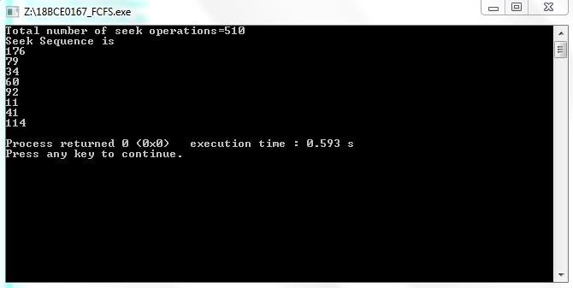

1. **SSTF Disk Scheduling Algorithm CODE:**

#include<stdio.h>

#include<stdlib.h>

#include<math.h>

void main()

{

int queue[100], t[100], head, seek=0,n,i,j,temp;

float avg;

printf("Enter the size of Queue\t");

scanf("%d",&n);

printf("Enter the queue\t");

for(i=0; i<n; i++)

{

scanf("%d",&queue[i]);

}

printf("Enter the initial head position\t");

scanf("%d",&head);

for(i=1; i<n; i++)

{

for(j=i+1; j<n; j++)

{

if(t[i]>t[j])

{

temp=t[i];

t[i]=t[j];

t[j]=temp;

temp=queue[i];

queue[i]=queue[j];

queue[j]=temp;

}

}

}

for(i=1; i<n-1; i++)

{

seek=seek+abs(head - queue[i]);

head=queue[i];

}

printf("\n Total seek time is %d\t",seek);

avg=seek/(float)n;

printf("\n Average seek time is %f\t",avg);

}

**OUTPUT**:

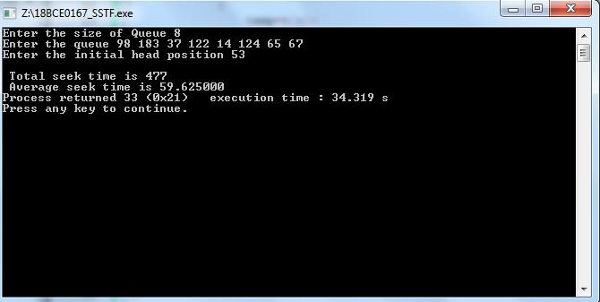

1. **SCAN Disk Scheduling Algorithm CODE:**

#include<iostream>

#include<stdlib.h>

#include<vector>

#include<algorithm>

using namespace std;

int size=8;

int disk_size=200;

void SCAN(int arr[], int head, string direction)

{

int seek_count = 0;

int distance, cur_track;

vector<int> left, right;

vector<int> seek_sequence;

if(direction == "left")

left.push_back(0);

else if(direction == "right")

right.push_back(disk_size - 1);

for(int i=0; i<size; i++){

if(arr[i]<head)

left.push_back(arr[i]);

if(arr[i]>head)

right.push_back(arr[i]);

}

sort(left.begin(), left.end());

sort(right.begin(), right.end());

int run=2;

while(run--){

if(direction == "left"){

for(int i=left.size()-1; i>=0; i--){

cur_track = left[i];

seek_sequence.push_back(cur_track);

distance=abs(cur_track-head);

seek_count += distance;

head = cur_track;

}

direction = "right";

}

else if(direction == "right"){

for(int i=0; i<right.size(); i++){

cur_track = right[i];

seek_sequence.push_back(cur_track);

distance= abs(cur_track-head);

seek_count += distance;

head = cur_track;

}

direction = "left";

}

}

cout<<"total number of seek operations = "

<<seek_count<<endl;

cout<<"Seek Sequence is" << endl;

for(int i=0; i<seek_sequence.size(); i++){

cout<<seek_sequence[i]<<endl;

}

}

int main()

{

int arr[size] = {176, 79, 34, 60, 92, 11, 41, 114};

int head=50;

string direction = "left";

SCAN(arr, head, direction);

return 0;

}

**OUTPUT:**

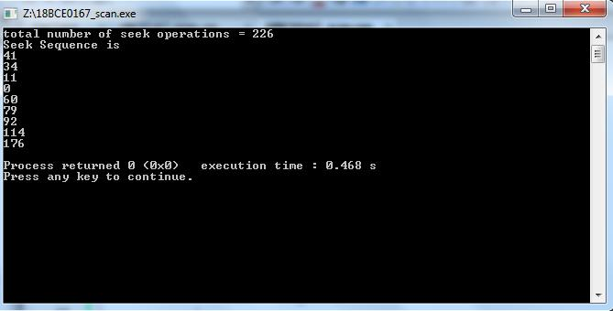

1. **CSCAN Disk Scheduling Algorithm CODE:**

#include<iostream>

#include<vector>

#include<stdlib.h>

#include<algorithm>

using namespace std;

int size = 8;

int disk_size = 200;

void CSCAN(int arr[], int head)

{

int seek_count = 0;

int distance, cur_track;

vector<int> left, right;

vector<int> seek_sequence;

left.push_back(0);

right.push_back(disk_size-1);

for(int i=0; i<size; i++){

if(arr[i]<head)

left.push_back(arr[i]);

if(arr[i]>head)

right.push_back(arr[i]);

}

sort(left.begin(), left.end());

sort(right.begin(), right.end());

for(int i=0; i<right.size(); i++){

cur_track = right[i];

seek_sequence.push_back(cur_track);

distance =abs(cur_track-head);

seek_count += distance;

head = cur_track;

}

head = 0;

for(int i=0; i<left.size(); i++){

cur_track = left[i];

seek_sequence.push_back(cur_track);

distance =abs(cur_track-head);

seek_count += distance;

head = cur_track;

}

cout<< "Total number of seek operations ="

<< seek_count<<endl;

cout<< "Seek sequence is"<<endl;

for(int i=0; i<seek_sequence.size(); i++){

cout<< seek_sequence[i] << endl;

}

}

int main()

{

int arr[size] = {176, 79, 34, 60, 92, 11, 41, 114};

int head=50;

cout<< "Initial position of head:"<< head<<endl;

CSCAN(arr, head);

return 0;

}

**OUTPUT:**

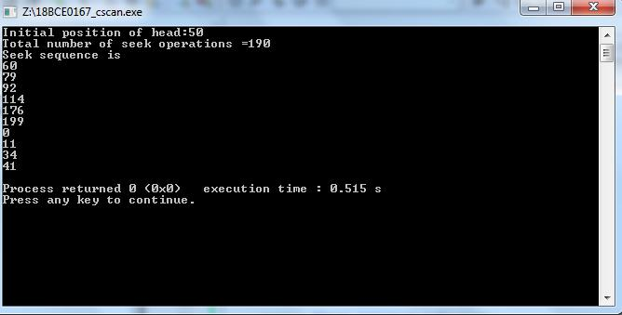

1. **LOOK Disk Scheduling Algorithm CODE:**

#include<iostream>

#include<vector>

#include<stdlib.h>

#include<algorithm>

using namespace std;

int size = 8;

int disk_size = 200;

void LOOK(int arr[], int head, string direction)

{

int seek_count = 0;

int distance, cur_track;

vector<int> left, right;

vector<int> seek_sequence;

for (int i = 0; i < size; i++) {

if (arr[i] < head)

left.push_back(arr[i]);

if (arr[i] > head)

right.push_back(arr[i]);

}

sort(left.begin(), left.end());

sort(right.begin(), right.end());

int run = 2;

while (run--) {

if (direction == "left") {

for (int i = left.size() - 1; i >= 0; i--) {

cur_track = left[i];

seek_sequence.push_back(cur_track);

distance = abs(cur_track - head);

seek_count += distance;

head = cur_track;

}

direction = "right";

}

else if (direction == "right") {

for (int i = 0; i < right.size(); i++) {

cur_track = right[i];

seek_sequence.push_back(cur_track);

distance = abs(cur_track - head);

seek_count += distance;

head = cur_track;

}

direction = "left";

}

}

cout << "Total number of seek operations = "

<< seek_count << endl;

cout << "Seek Sequence is" << endl;

for (int i = 0; i < seek_sequence.size(); i++) {

cout << seek_sequence[i] << endl;

}

}

int main()

{

int arr[size] = { 176, 79, 34, 60,

92, 11, 41, 114 };

int head = 50;

string direction = "right";

cout << "Initial position of head: "

* head << endl;

LOOK(arr, head, direction);

return 0;

}

**OUTPUT**:

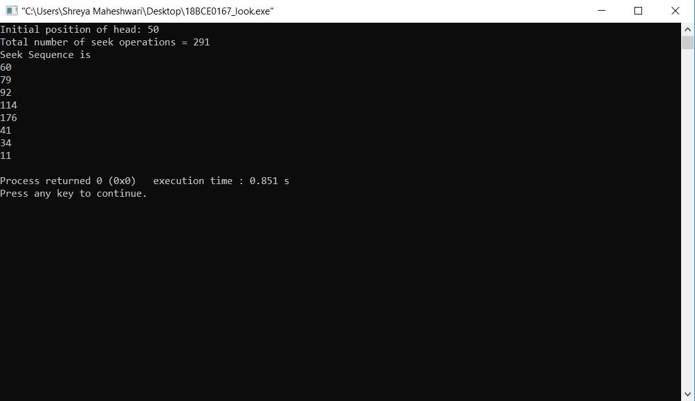

1. **C-LOOK Disk Scheduling Algorithm CODE:**

#include<iostream>

#include<vector>

#include<stdlib.h>

#include<algorithm>

using namespace std;

int size = 8;

int disk_size = 200;

void CLOOK(int arr[], int head)

{

int seek_count = 0;

int distance, cur_track;

vector<int> left, right;

vector<int> seek_sequence;

for (int i = 0; i < size; i++) {

if (arr[i] < head)

left.push_back(arr[i]);

if (arr[i] > head)

right.push_back(arr[i]);

}

sort(left.begin(), left.end());

sort(right.begin(), right.end());

for (int i = 0; i < right.size(); i++) {

cur_track = right[i];

seek_sequence.push_back(cur_track);

distance = abs(cur_track - head);

seek_count += distance;

head = cur_track;

}

seek_count += abs(head - left[0]);

head = left[0];

for (int i = 0; i < left.size(); i++) {

cur_track = left[i];

seek_sequence.push_back(cur_track);

distance = abs(cur_track - head);

seek_count += distance;

head = cur_track;

}

cout << "Total number of seek operations = "

<< seek_count << endl;

cout << "Seek Sequence is" << endl;

for (int i = 0; i < seek_sequence.size(); i++) {

cout << seek_sequence[i] << endl;

}

}

int main()

{

int arr[size] = { 176, 79, 34, 60,

92, 11, 41, 114 };

int head = 50;

cout << "Initial position of head: " << head << endl;

CLOOK(arr, head);

return 0;

}

**OUTPUT**:

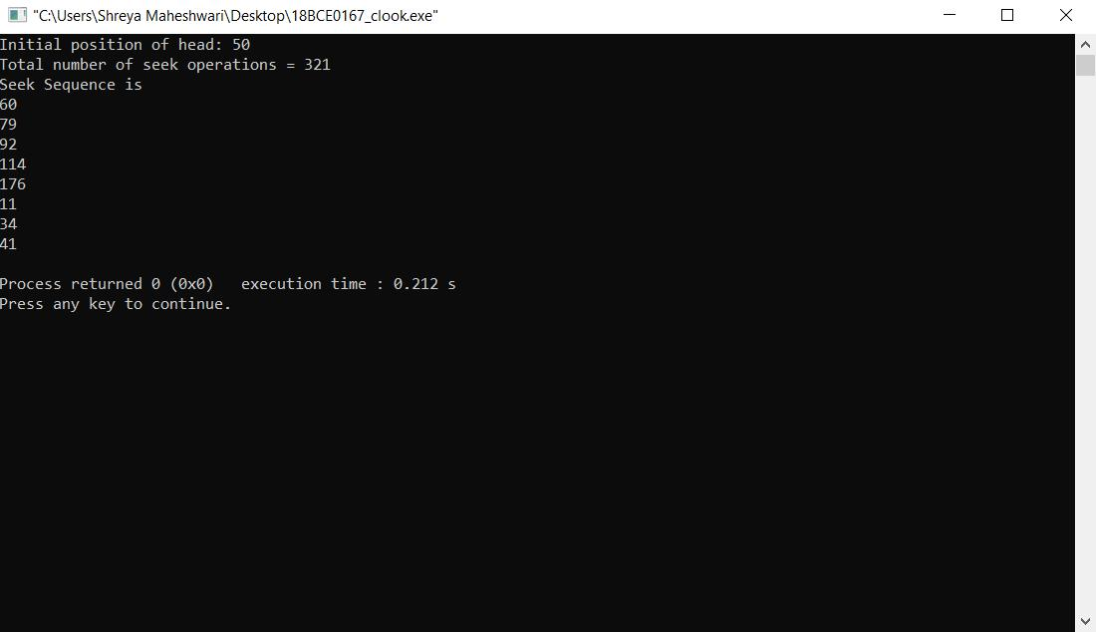

**WRITTEN NOTES:**

**OS LAB ASSIGNMENT**

**ACTIVITY 9**

Name: Shreya Maheshwari

Registration number: 18BCE0167

**CIGARETTE SMOKER**

**CODE:**

#include <pthread.h>

#include <semaphore.h>

#include <stdbool.h>

#include <stdio.h>

#include <stdlib.h>

#include <errno.h>

#include <unistd.h>

sem_t smoker_waits[3];

sem_t agent;

typedef void *(*smokers_t)(void *);

void* smoker_0(void* arg)

{

while (true)

{

nanosleep((struct timespec[]){{0, rand() % 200000000}}, NULL); printf("Smoker zero waiting to smoke (has paper)\n");

sem_wait(&smoker_waits[0]);

printf("Smoker zero received matchges and tobacco. Now making cigarette.\n"); sem_post(&agent);

}

return NULL;

}

void* smoker_1(void* arg)

{

while (true)

{

nanosleep((struct timespec[]){{0, rand() % 200000000}}, NULL); printf("Smoker one waiting to smoke (has matches)\n");

sem_wait(&smoker_waits[1]);

printf("Smoker zero received matches and tobacco. Now making cigarette.\n"); sem_post(&agent);

}

return NULL;

}

void* smoker_2(void* arg)

{

while (true)

{

nanosleep((struct timespec[]){{0, rand() % 200000000}}, NULL); printf("Smoker two waiting to smoke (has tobacco)\n");

sem_wait(&smoker_waits[2]);

printf("Smoker zero received matches and tobacco. Now making cigarette.\n"); sem_post(&agent);

}

return NULL;

}

int main(int argc, char* arvg[])

{

srand(time(NULL));

sem_init(&agent, 0, 1);

pthread_t smoker_threads[3];

smokers_t smoker_functions[3] = { smoker_0, smoker_1, smoker_2 };

for (int i = 0; i < 3; ++i)

{

sem_init(&smoker_waits[i], 0, 0);

if(pthread_create(&smoker_threads[i], NULL, smoker_functions[i], NULL) == EAGAIN) {

perror("Insufficent resources to create thread\n"); return 0;

}

}

while (true)

{

sem_wait(&agent);

sem_post(&smoker_waits[rand() % 2]);

}

for (int i = 0; i < 3; ++i)

{

pthread_join(smoker_threads[i], NULL);

}

}

OUTPUT:

Online Compiler: The code is run on **repl.it**

**(Lab’s telnet was not working; hence, online compiler is used)**

**Account:**

Name: Shreya Maheshwari

Username: @mshreya9

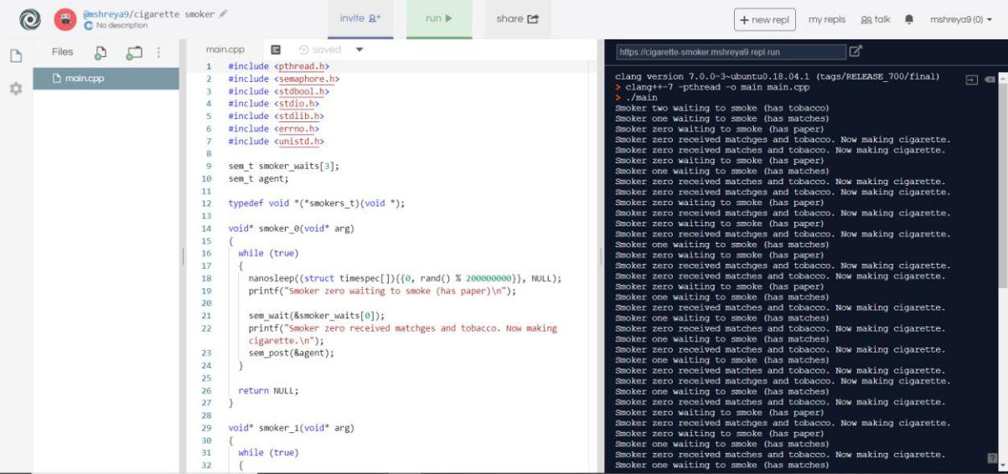

**SLEEPING BARBER PROBLEM:**

CODE:

#include <stdio.h>

#include <unistd.h>

#include <stdlib.h>

#include <pthread.h>

#include <semaphore.h>

#define MAX_CUSTOMERS 25

void *customer(void *num);

void *barber(void *);

void randwait(int secs);

* waitingRoom Limits the # of customers allowed to enter the waiting room at one time. sem_t waitingRoom;
* barberChair ensures mutually exclusive access to the barber chair.

sem_t barberChair;

* barberPillow is used to allow the barber to sleep until a customer arrives. sem_t barberPillow;
* seatBelt is used to make the customer to wait until the barber is done cutting his/her hair. sem_t seatBelt;
* Flag to stop the barber thread when all customers have been serviced.

int allDone = 0;

int main(int argc, char *argv[])

{

pthread_t btid;

pthread_t tid[MAX_CUSTOMERS];

int i, x, numCustomers, numChairs; int Number[MAX_CUSTOMERS];

printf("Maximum number of customers can only be 25. Enter number of customers and chairs.\n");

scanf("%d",&x);

numCustomers = x;

scanf("%d",&x);

numChairs = x;

if (numCustomers > MAX_CUSTOMERS) {

printf("The maximum number of Customers is %d.\n", MAX_CUSTOMERS);

system("PAUSE");

return 0;

}

printf("A solution to the sleeping barber problem using semaphores.\n"); for (i = 0; i < MAX_CUSTOMERS; i++) {

Number[i] = i;

}

* Initialize the semaphores with initial values...

sem_init(&waitingRoom, 0, numChairs); sem_init(&barberChair, 0, 1); sem_init(&barberPillow, 0, 0); sem_init(&seatBelt, 0, 0);

* Create the barber.

pthread_create(&btid, NULL, barber, NULL);

// Create the customers.

for (i = 0; i < numCustomers; i++) {

pthread_create(&tid[i], NULL, customer, (void *)&Number[i]);

}

* Join each of the threads to wait for them to finish. for (i = 0; i < numCustomers; i++) {

pthread_join(tid[i],NULL);

}

* When all of the customers are finished, kill the barber thread. allDone = 1;

sem_post(&barberPillow); // Wake the barber so he will exit. pthread_join(btid,NULL);

system("PAUSE"); return 0;

}

void *customer(void *number) {

int num = *(int *)number; // Leave for the shop and take some random amount of time to arrive.

printf("Customer %d leaving for barber shop.\n", num); randwait(5);

printf("Customer %d arrived at barber shop.\n", num); // Wait for space to open up in

the waiting room...

sem_wait(&waitingRoom);

printf("Customer %d entering waiting room.\n", num); // Wait for the barber chair to become free.

sem_wait(&barberChair); // The chair is free so give up your spot in the waiting room. sem_post(&waitingRoom); // Wake up the barber... printf("Customer %d waking the barber.\n", num);

sem_post(&barberPillow); // Wait for the barber to finish cutting your hair. sem_wait(&seatBelt); // Give up the chair. sem_post(&barberChair);

printf("Customer %d leaving barber shop.\n", num);

}

void *barber(void *junk)

{

* While there are still customers to be serviced... Our barber is omnicient and can tell if there are customers still on the way to his shop.

while (!allDone) { // Sleep until someone arrives and wakes you..

printf("The barber is sleeping\n");

sem_wait(&barberPillow); // Skip this stuff at the end...

if (!allDone)

{ // Take a random amount of time to cut the customer's hair. printf("The barber is cutting hair\n");

randwait(3);

printf("The barber has finished cutting hair.\n"); // Release the customer when done

cutting...

sem_post(&seatBelt);

}

else {

printf("The barber is going home for the day.\n");

}

}

}

void randwait(int secs) {

int len = 1;

sleep(len);

}

OUTPUT:

Online Compiler: The code is run on **repl.it**

**(Lab’s telnet was not working; hence, online compiler is used)**

**Account:**

Name: Shreya Maheshwari

Username: @mshreya9

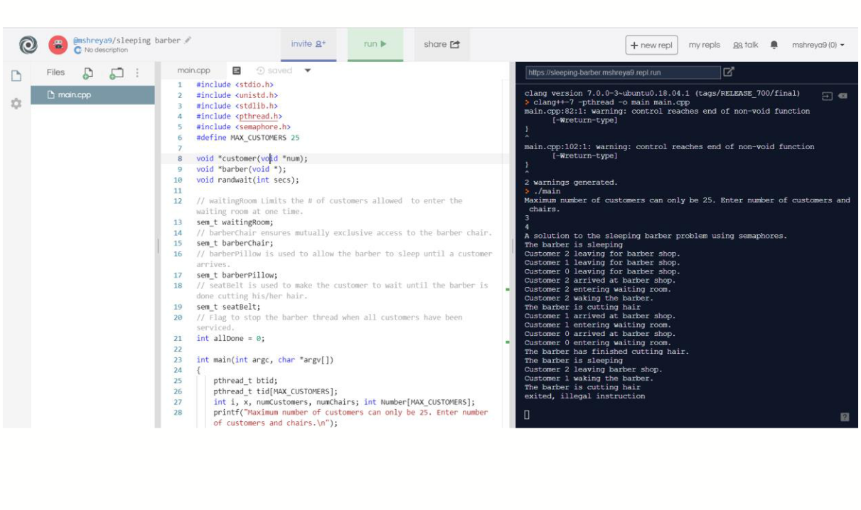

**BARRIER IMLPEMENTATION**

#include <stdlib.h>

#include <unistd.h>

#include <stdio.h>

#include <assert.h>

#include <pthread.h>

static int nthread = 1;

static int round = 0;

struct barrier {

pthread_mutex_t barrier_mutex;

pthread_cond_t barrier_cond;

|  |  |
| --- | --- |
| int nthread; | // Number of threads that have reached this round of the |
| barrier |  |
| int round; | // Barrier round |
| } bstate; |  |
|  |  |

static void

barrier_init(void)

{

assert(pthread_mutex_init(&bstate.barrier_mutex, NULL) == 0); assert(pthread_cond_init(&bstate.barrier_cond, NULL) == 0); bstate.nthread = 0;

}

static void

barrier()

{

pthread_mutex_lock(&bstate.barrier_mutex); bstate.nthread++;

if (bstate.nthread == nthread) {

pthread_cond_broadcast(&bstate.barrier_cond);

bstate.nthread = 0;

bstate.round++;

}

else {

pthread_cond_wait(&bstate.barrier_cond, &bstate.barrier_mutex);

}

pthread_mutex_unlock(&bstate.barrier_mutex);

}

static void *

thread(void *xa)

{

long n = (long) xa;

long delay;

int i;

for (i = 0; i < 20000; i++) {

int t = bstate.round;

assert (i == t);

barrier();

usleep(random() % 100);

}

}

int

main(int argc, char *argv[])

{

pthread_t *tha;

void *value;

long i;

double t1, t0;

if (argc < 2) {

fprintf(stderr, "%s: %s nthread\n", argv[0], argv[0]); exit(-1);

}

nthread = atoi(argv[1]);

tha = malloc(sizeof(pthread_t) * nthread); srandom(0);

barrier_init();

for(i = 0; i < nthread; i++) {

assert(pthread_create(&tha[i], NULL, thread, (void *) i) == 0);

}

for(i = 0; i < nthread; i++) { assert(pthread_join(tha[i], &value) == 0);

}

printf("OK; passed\n");

}

Online Compiler: The code is run on **repl.it**

**(Lab’s telnet was not working; hence, online compiler is used)**

**Account:**

Name: Shreya Maheshwari

Username: @mshreya9

**The implementation of the above code was not done on the online compiler, as shown in the output screen**

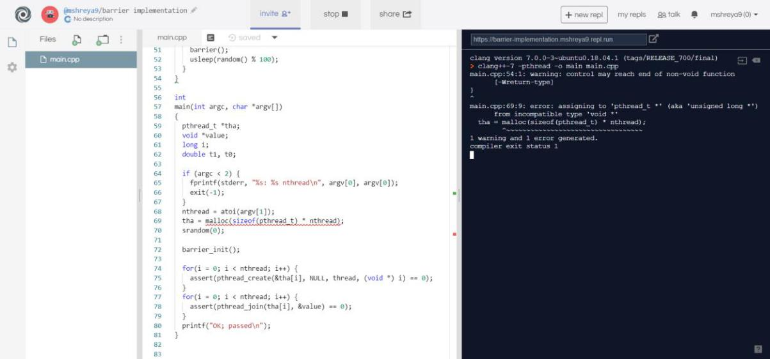

**WRITTEN NOTES**

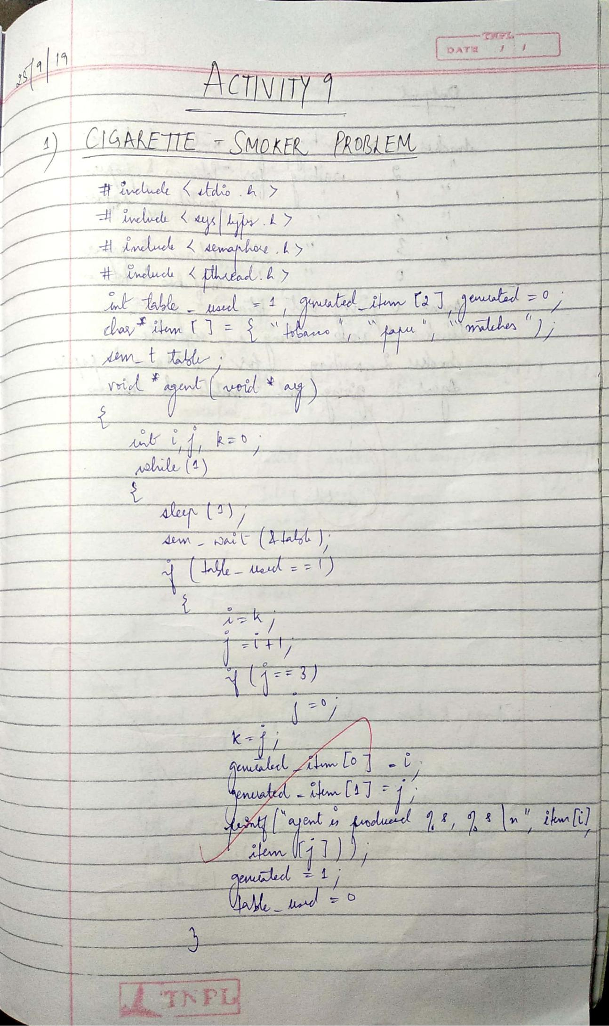

Scanned by CamScanner

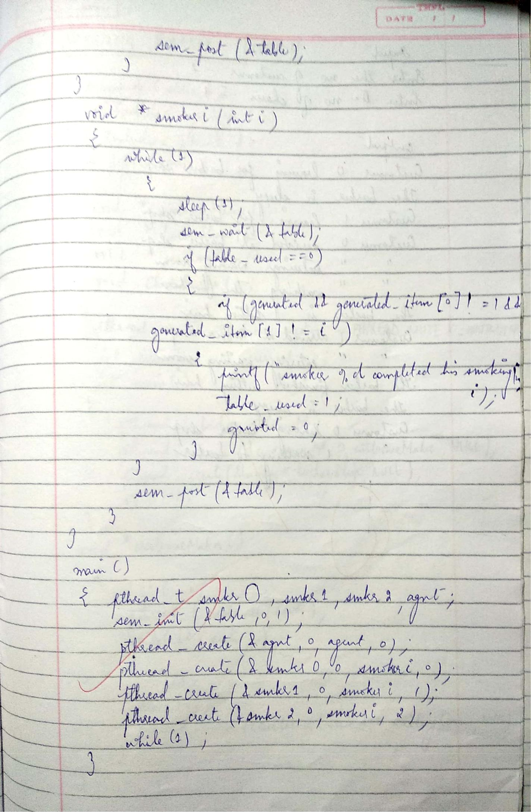

Scanned by CamScanner

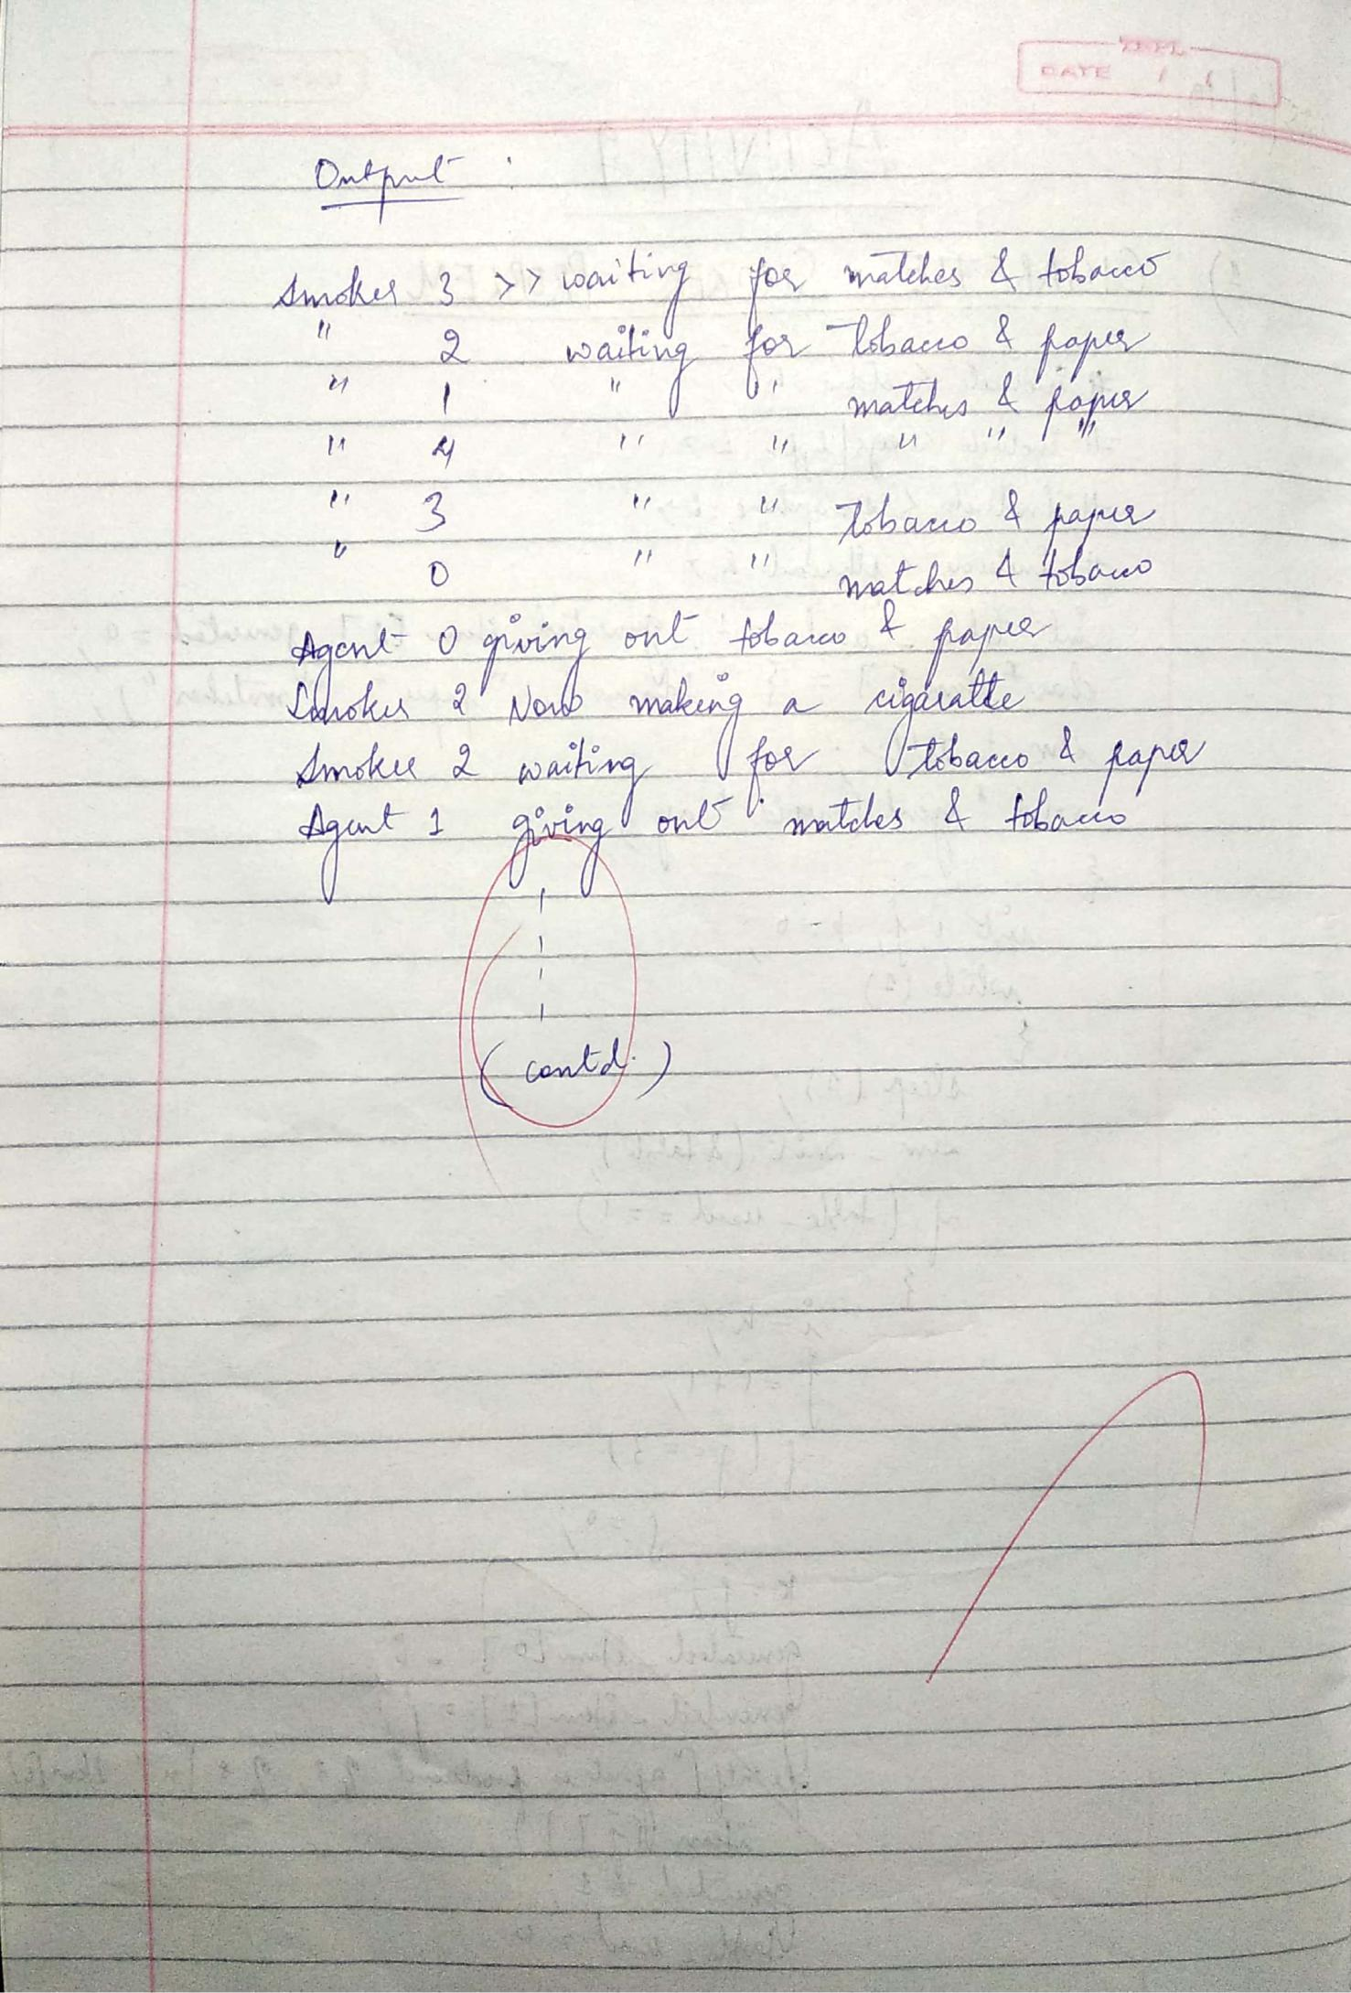

Scanned by CamScanner

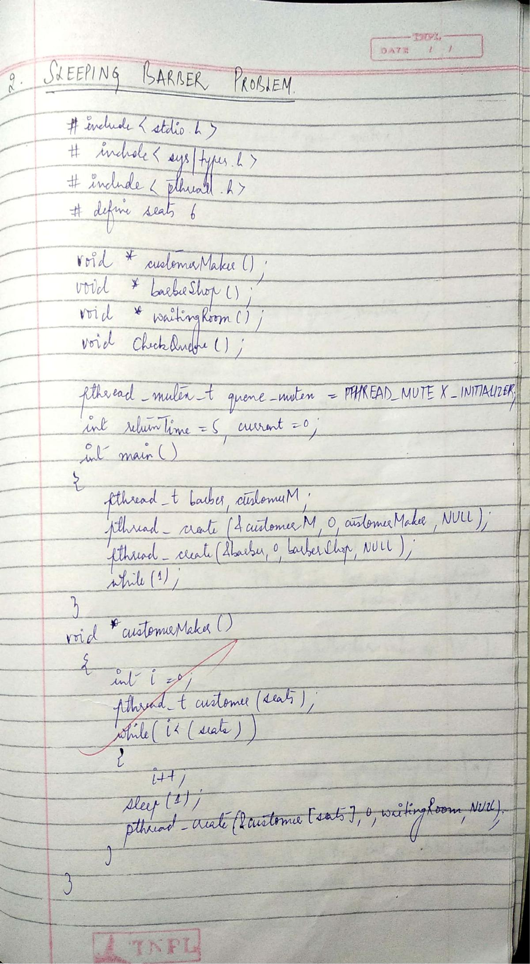

Scanned by CamScanner

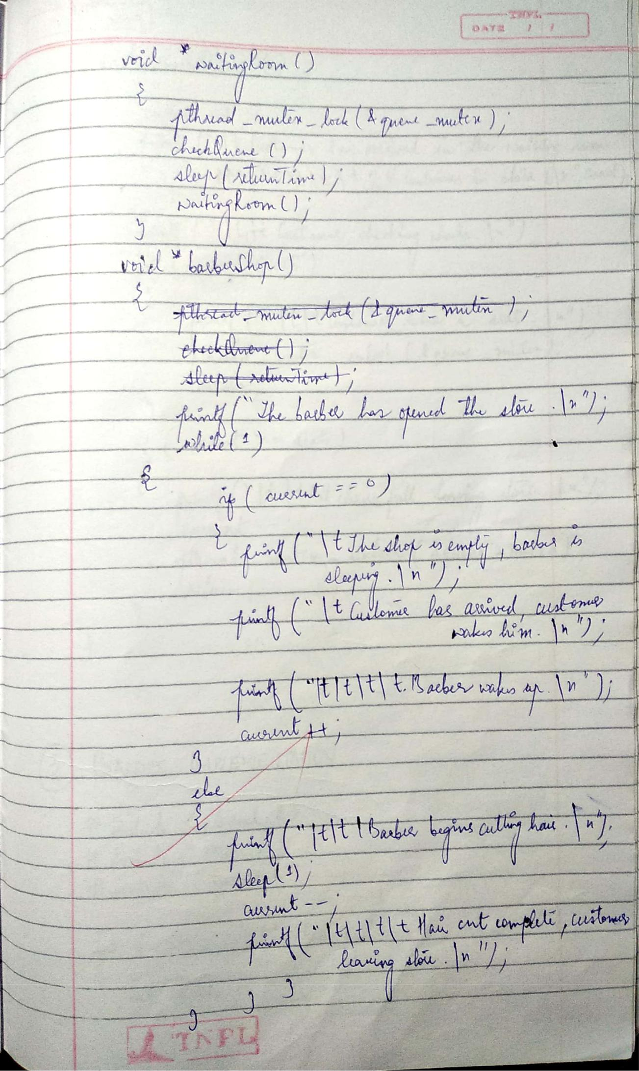

Scanned by CamScanner

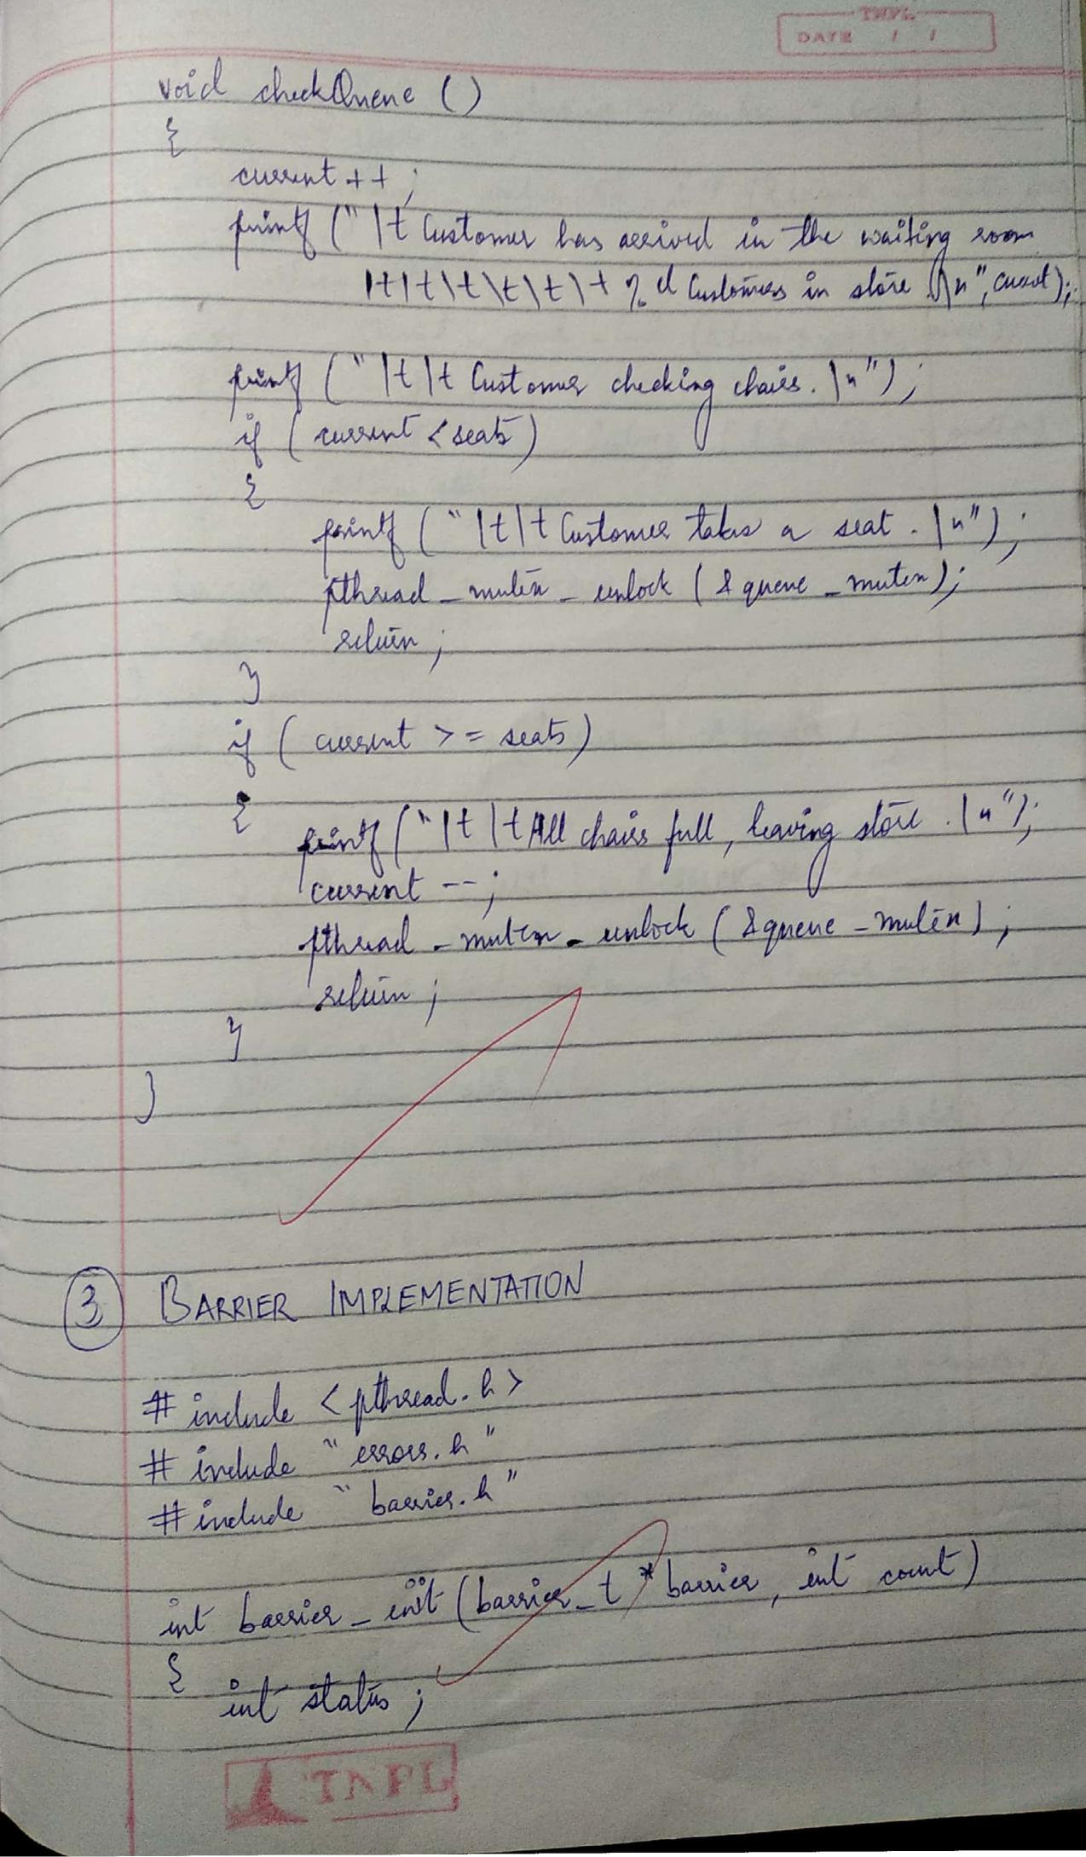

Scanned by CamScanner

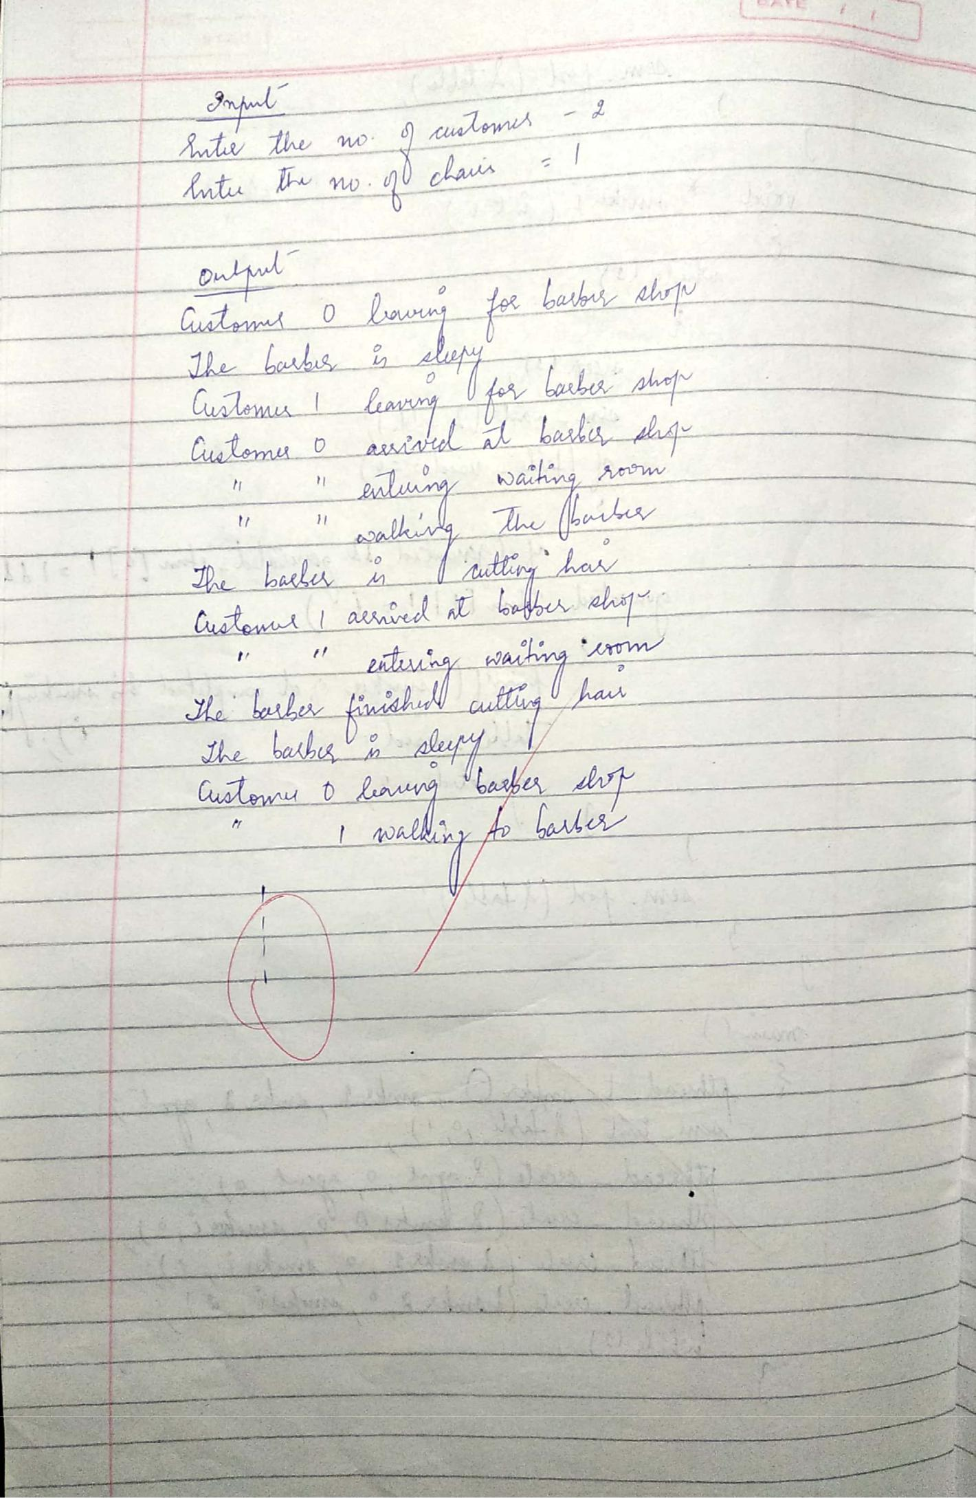

Scanned by CamScanner

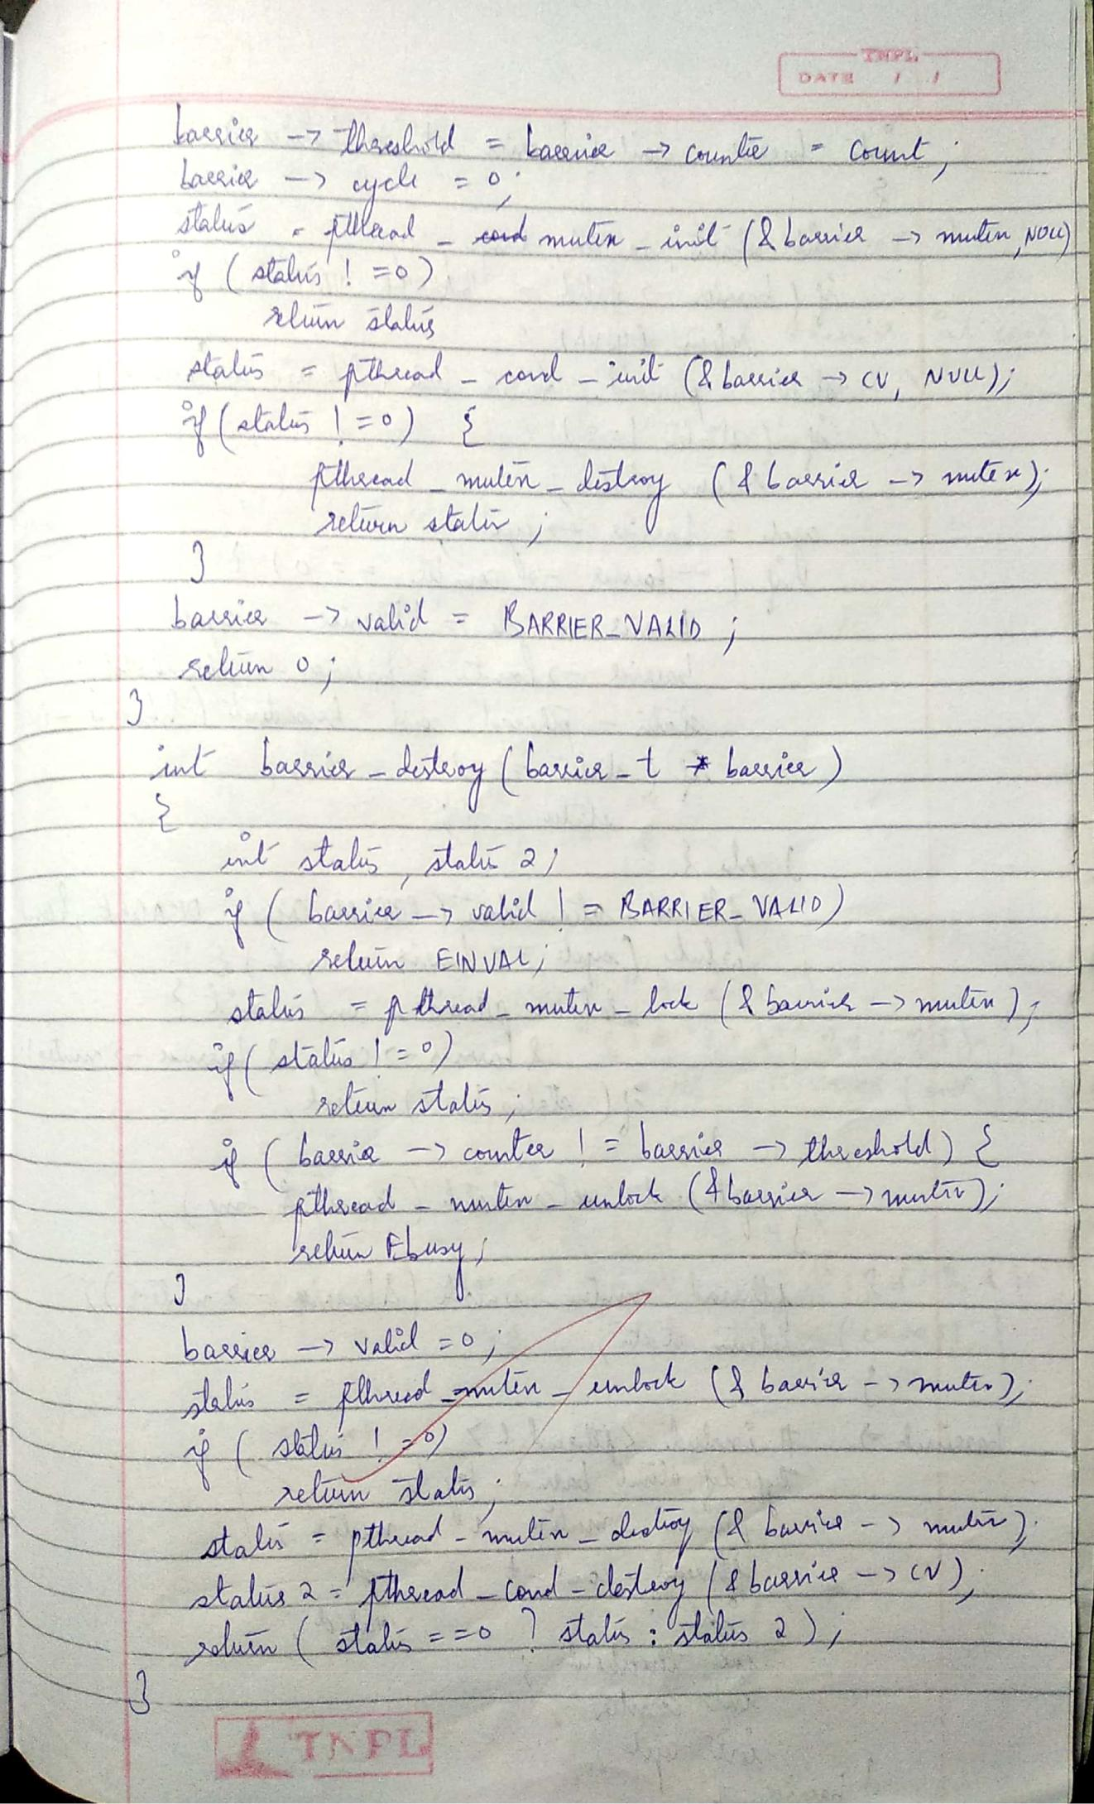

Scanned by CamScanner

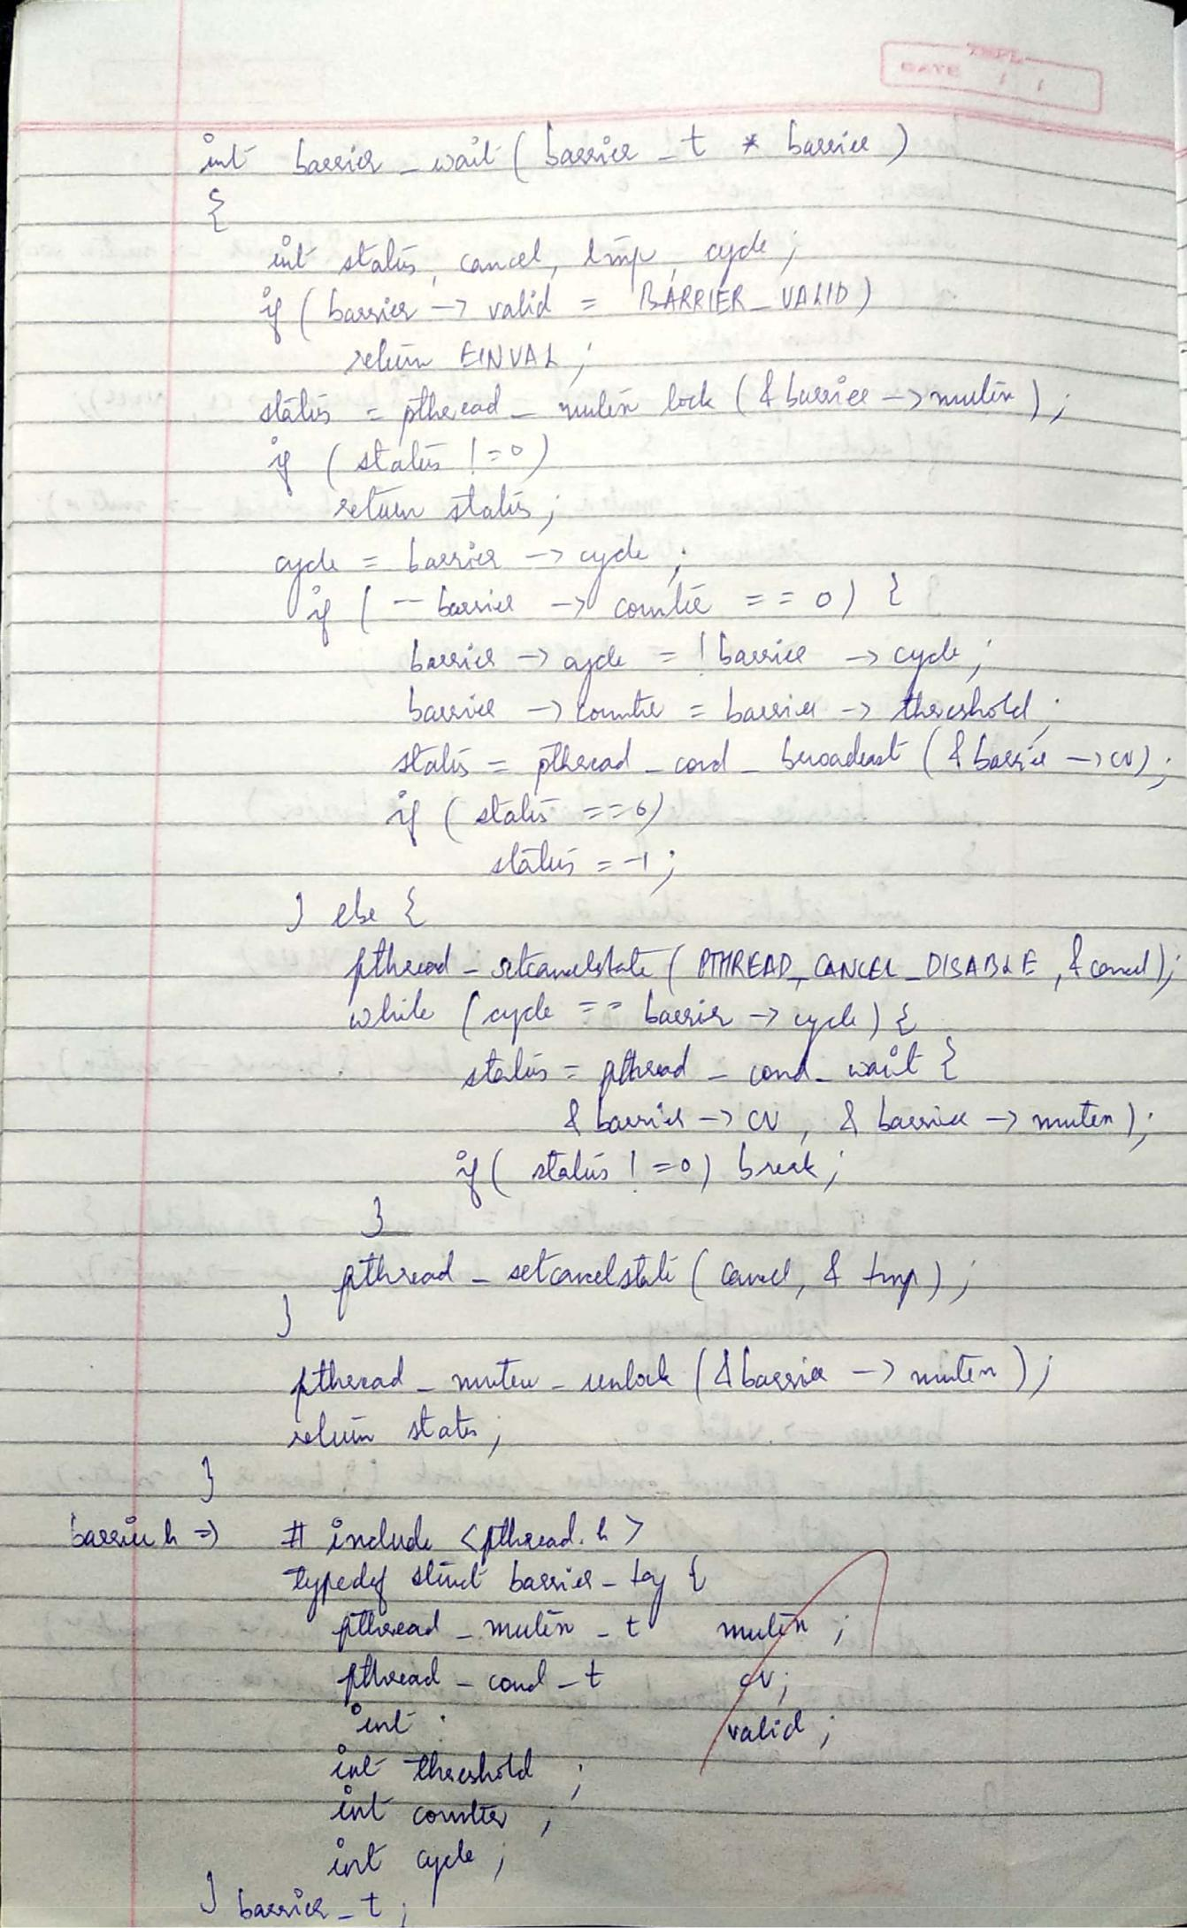

Scanned by CamScanner

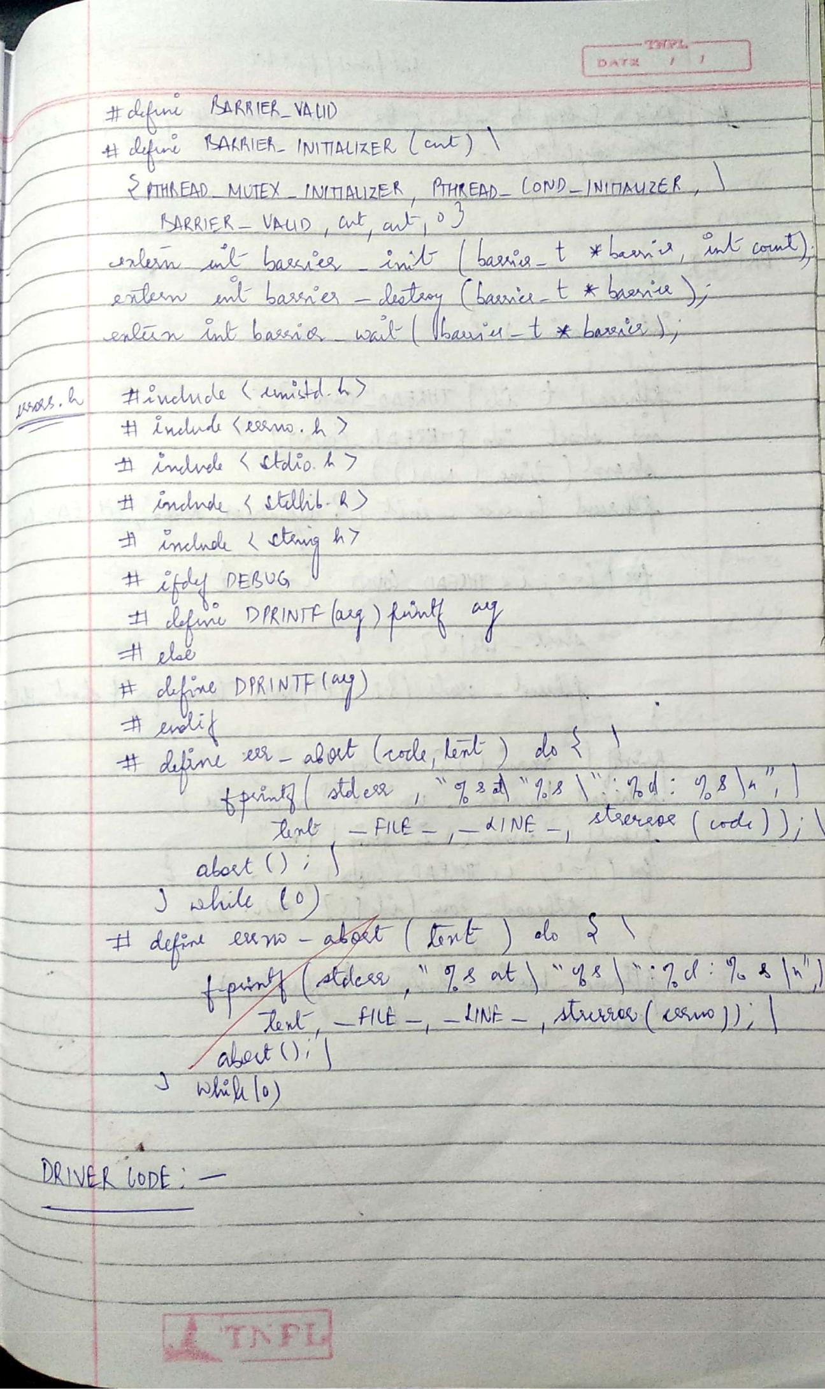

Scanned by CamScanner

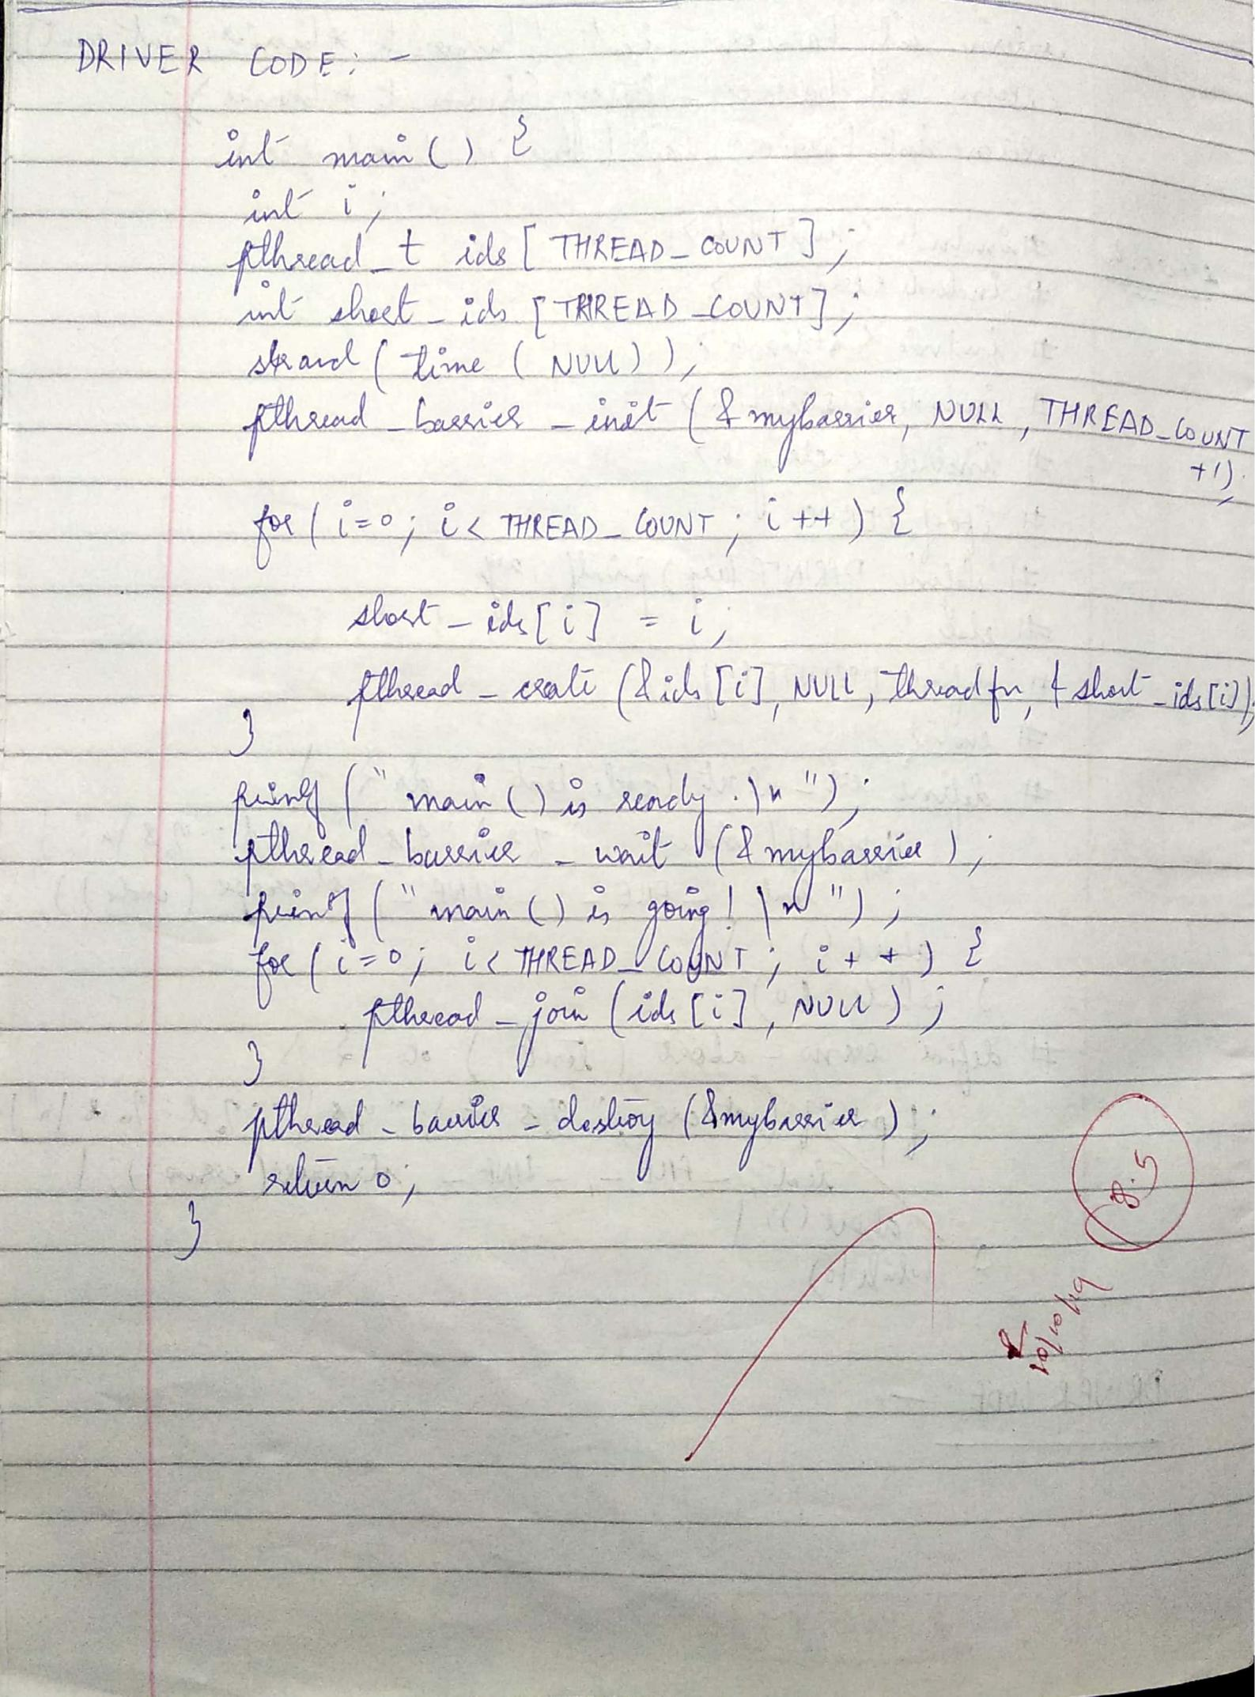

Scanned by CamScanner

**ASSIGNMENT 8**

NAME: SHREYA MAHESHWARI

REGISTRATION NUMBER: 18BCE0167

DINING-PHILOSOPHER PROBLEM

CODE:

#include <pthread.h>

#include <semaphore.h>

#include <stdio.h>

#define N 5

#define THINKING 2

#define HUNGRY 1

#define EATING 0

#define LEFT (phnum + 4) % N

#define RIGHT (phnum + 1) % N

int state[N];

int phil[N] = { 0, 1, 2, 3, 4 };

sem_t mutex;

sem_t S[N];

void test(int phnum)

{

if (state[phnum] == HUNGRY

* state[LEFT] != EATING
* state[RIGHT] != EATING) { // state that eating state[phnum] = EATING;

sleep(2);

printf("Philosopher %d takes fork %d and %d\n", phnum + 1, LEFT + 1, phnum + 1);

printf("Philosopher %d is Eating\n", phnum + 1);

* sem_post(&S[phnum]) has no effect
* during takefork
* used to wake up hungry philosophers
* during putfork

sem_post(&S[phnum]);

}

}

// take up chopsticks

void take_fork(int phnum)

{

sem_wait(&mutex);

* state that hungry state[phnum] = HUNGRY;

printf("Philosopher %d is Hungry\n", phnum + 1);

* eat if neighbours are not eating test(phnum);

sem_post(&mutex);

* if unable to eat wait to be signalled sem_wait(&S[phnum]);

sleep(1);

}

* put down chopsticks void put_fork(int phnum)

{

sem_wait(&mutex);

* state that thinking state[phnum] = THINKING;

printf("Philosopher %d putting fork %d and %d down\n", phnum + 1, LEFT + 1, phnum + 1);

printf("Philosopher %d is thinking\n", phnum + 1);

test(LEFT);

test(RIGHT);

sem_post(&mutex);

}

void* philospher(void* num)

{

while (1) {

int* i = num;

sleep(1);

take_fork(*i);

sleep(0);

put_fork(*i);

}

}

int main()

{

int i;

pthread_t thread_id[N];

* initialize the semaphores sem_init(&mutex, 0, 1);

for (i = 0; i < N; i++)

sem_init(&S[i], 0, 0);

for (i = 0; i < N; i++) {

* create philosopher processes pthread_create(&thread_id[i], NULL,

philospher, &phil[i]);

printf("Philosopher %d is thinking\n", i + 1);

}

for (i = 0; i < N; i++)

pthread_join(thread_id[i], NULL);

}

OUTPUT:

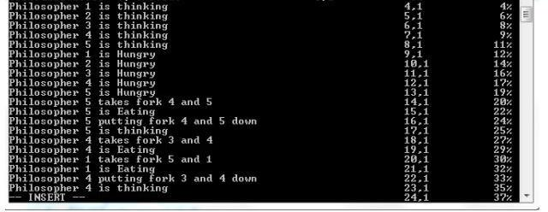

PRODUCER CONSUMER PROBLEM

CODE:

#include<stdio.h>

#include<stdlib.h>

int mutex=1, full=0, empty=3, x=0;

int main()

{

int n;

void producer();

void consumer();

int wait(int);

int signal(int);

printf("\n1.Producer \n 2.Consumer\n 3.Exit");

while(1)

{

printf("\n Enter your choice:");

scanf("%d",&n);

switch(n)

{

case 1: if((mutex==1) && (empty!=0))

producer();

else

printf("Buffer is full!!");

break;

case 2: if((mutex==1) && (full !=0))

consumer();

else

printf("Buffer is empty!!");

break;

case 3:

exit(0);

break;

}

}

return 0;

}

int wait(int s)

{

return(--s);

}

int signal(int s)

{

return(++s);

}

void producer()

{

mutex=wait(mutex);

full=signal(full);

empty=wait(empty);

x++;

printf("\n Producer produces the item %d",x);

mutex=signal(mutex);

}

void consumer()

{

mutex=wait(mutex);

full=wait(full);

empty=signal(empty);

printf("\n Consumer consumes item %d",x);

x--;

mutex=signal(mutex);

}

OUTPUT:

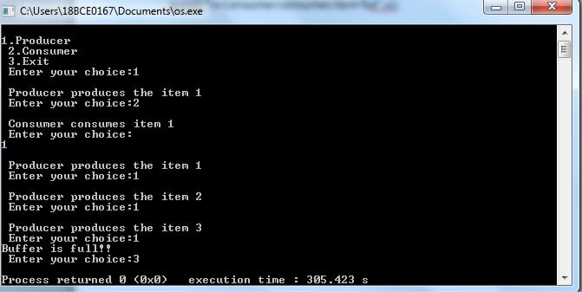

READER-WRITER PROBLEM:

CODE-

#include<semaphore.h>

#include<stdio.h>

#include<pthread.h>

* include<bits/stdc++.h> using namespace std;

void *reader(void *);

void *writer(void *);

int readcount=0,writecount=0,sh_var=5,bsize[5]; sem_t x,y,z,rsem,wsem;

pthread_t r[3],w[2];

void *reader(void *i)

{

cout << "\n ------------------------ ";

cout << "\n\n reader-" << i << " is reading";

sem_wait(&z);

sem_wait(&rsem);

sem_wait(&x);

readcount++;

if(readcount==1)

sem_wait(&wsem);

sem_post(&x);

sem_post(&rsem);

sem_post(&z);

cout << "\nupdated value :" << sh_var;

sem_wait(&x);

readcount--;

if(readcount==0)

sem_post(&wsem);

sem_post(&x);

}

void *writer(void *i)

{

cout << "\n\n writer-" << i << "is writing";

sem_wait(&y);

writecount++;

if(writecount==1)

sem_wait(&rsem);

sem_post(&y);

sem_wait(&wsem);

sh_var=sh_var+5;

sem_post(&wsem);

sem_wait(&y);

writecount--;

if(writecount==0)

sem_post(&rsem);

sem_post(&y);

}

int main()

{

sem_init(&x,0,1);

sem_init(&wsem,0,1);

sem_init(&y,0,1);

sem_init(&z,0,1);

sem_init(&rsem,0,1);

pthread_create(&r[0],NULL,(void *)reader,(void *)0); pthread_create(&w[0],NULL,(void *)writer,(void *)0);

pthread_create(&r[1],NULL,(void *)reader,(void *)1); pthread_create(&r[2],NULL,(void *)reader,(void *)2); pthread_create(&r[3],NULL,(void *)reader,(void *)3); pthread_create(&w[1],NULL,(void *)writer,(void *)3); pthread_create(&r[4],NULL,(void *)reader,(void *)4);

pthread_join(r[0],NULL);

pthread_join(w[0],NULL);

pthread_join(r[1],NULL);

pthread_join(r[2],NULL);

pthread_join(r[3],NULL);

pthread_join(w[1],NULL);

pthread_join(r[4],NULL);

return(0);

}

OUTPUT-

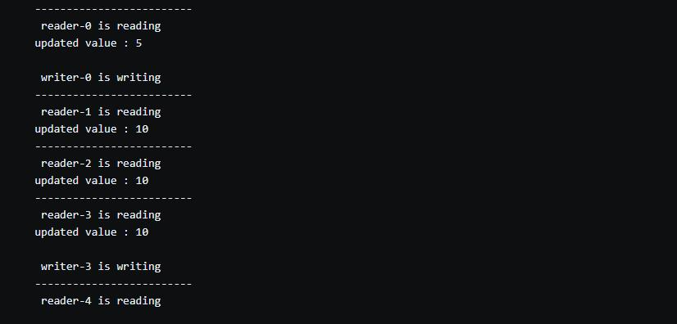

**WRITTEN NOTES:**

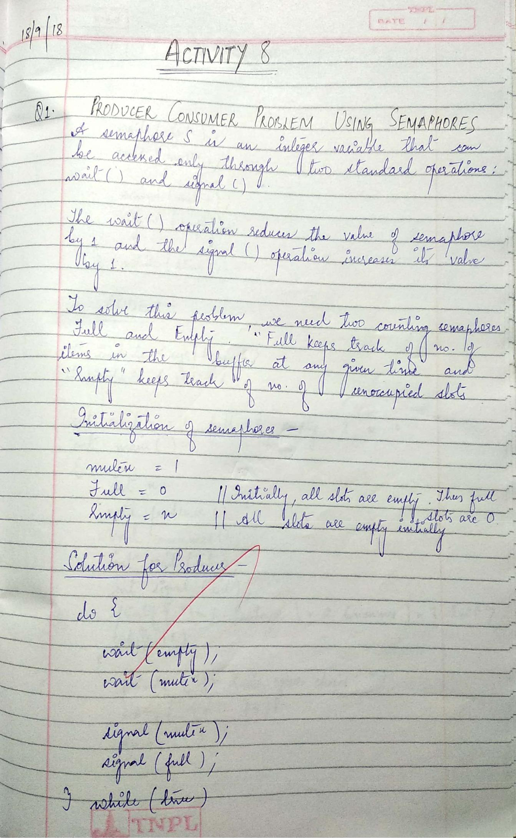

Scanned by CamScanner

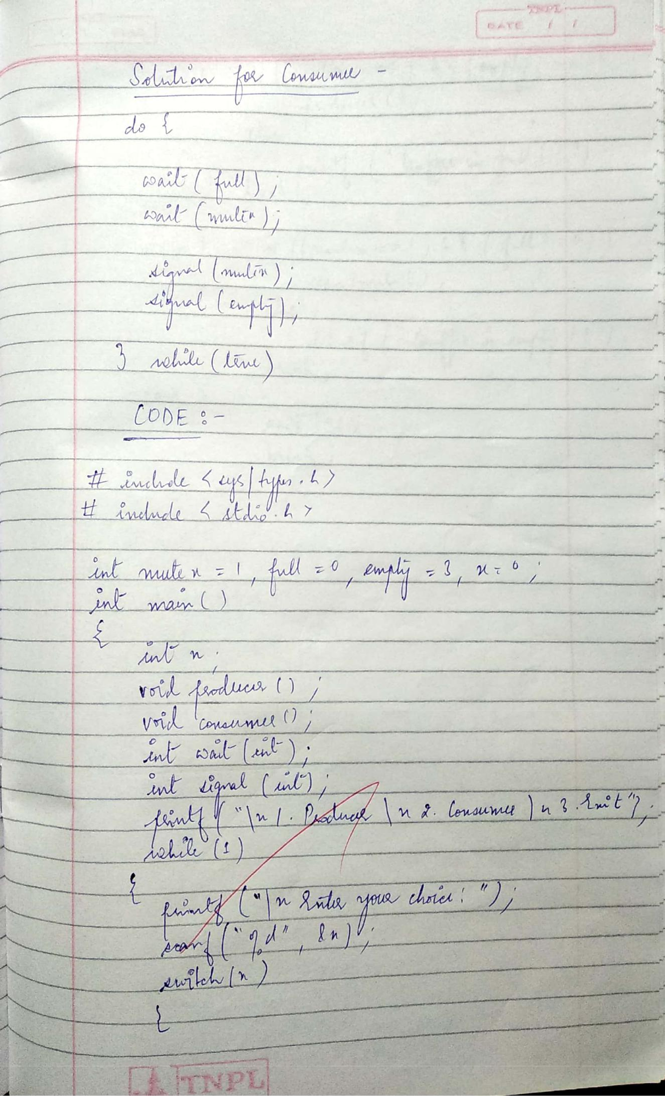

Scanned by CamScanner

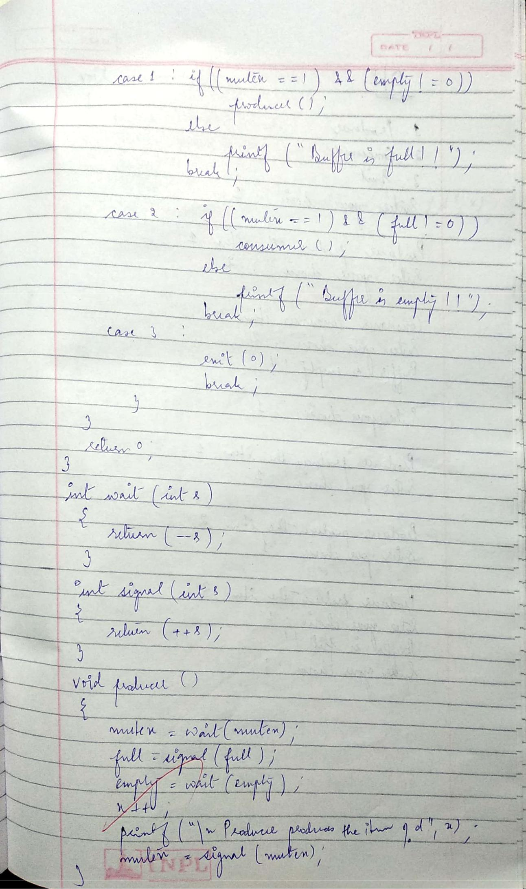

Scanned by CamScanner

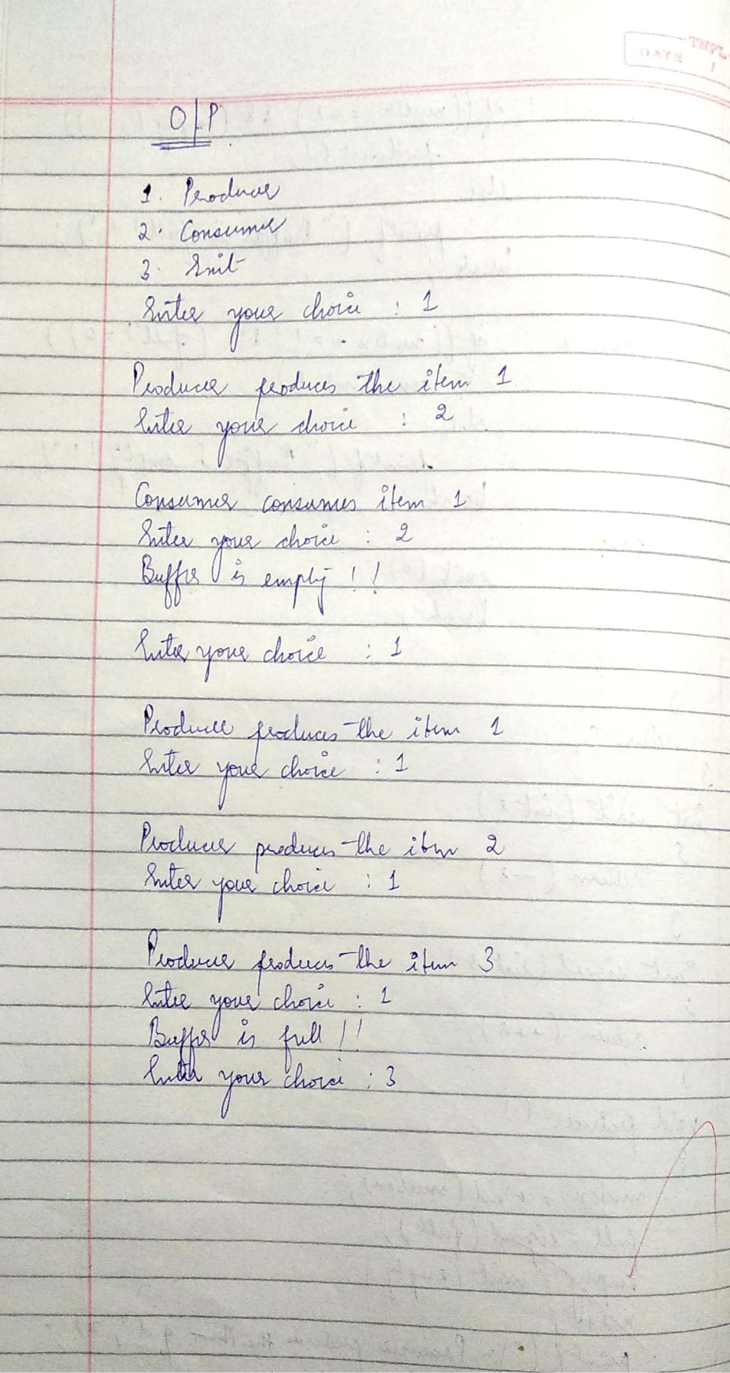

Scanned by CamScanner

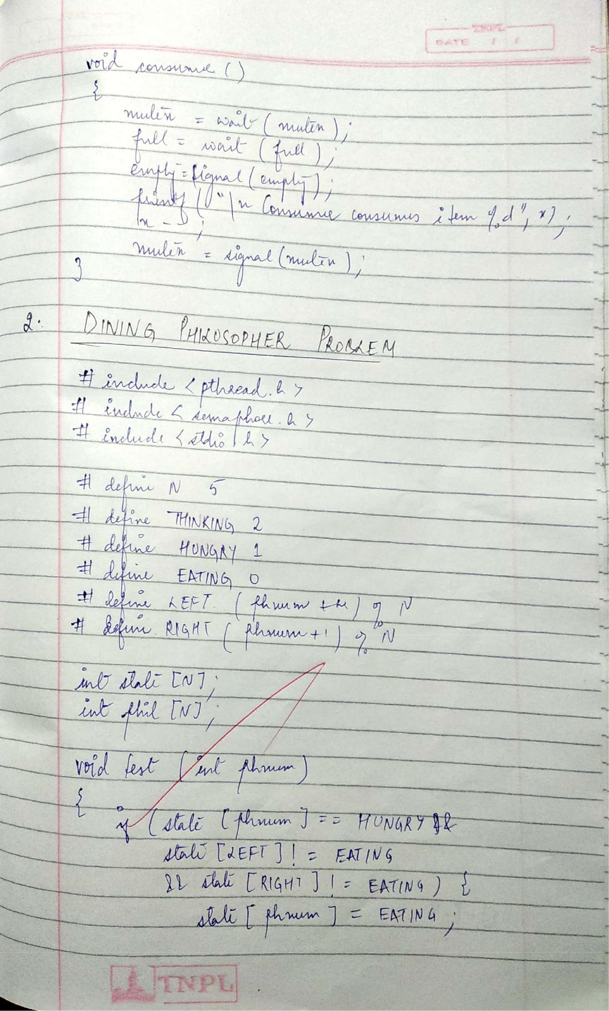

Scanned by CamScanner

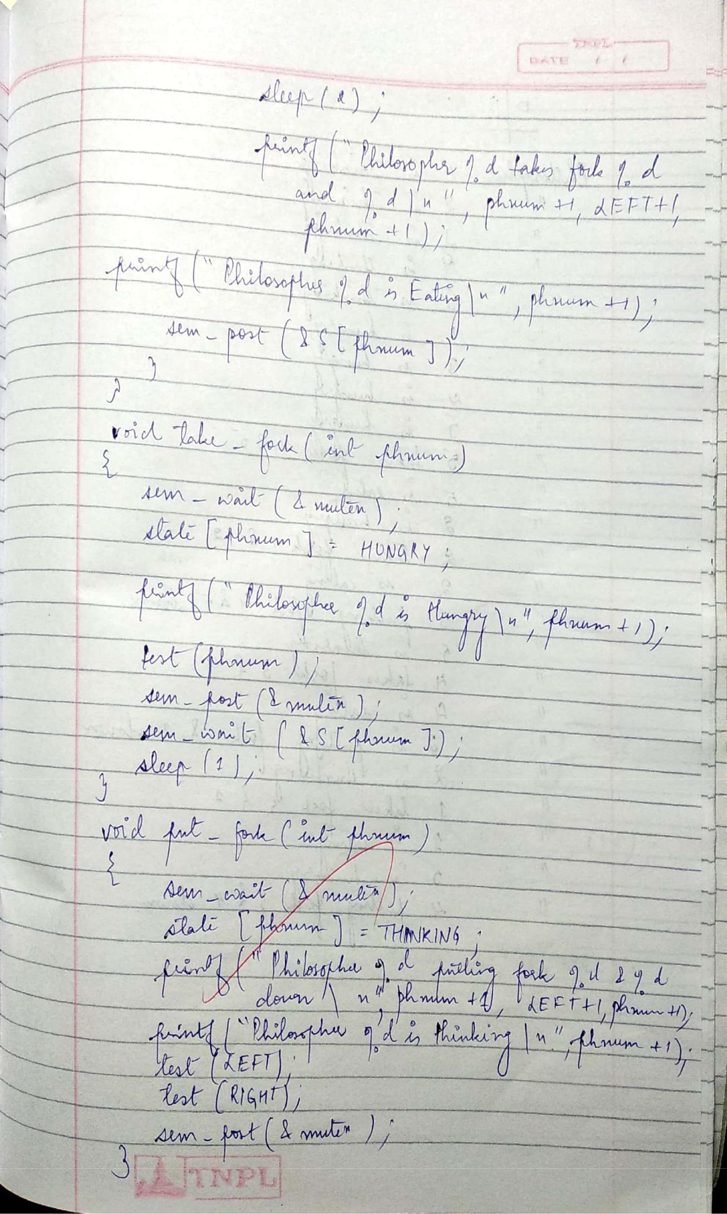

Scanned by CamScanner

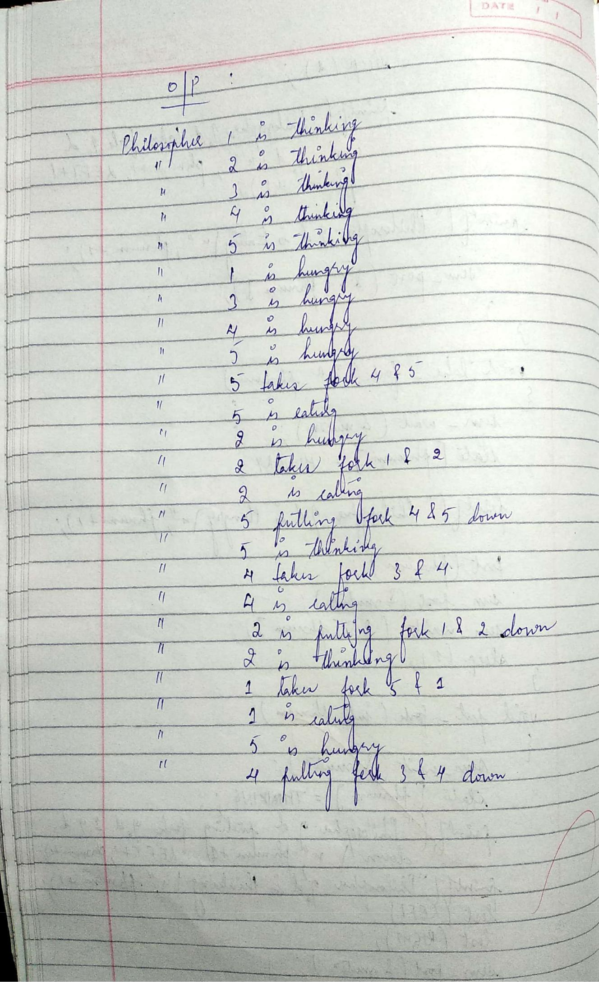

Scanned by CamScanner

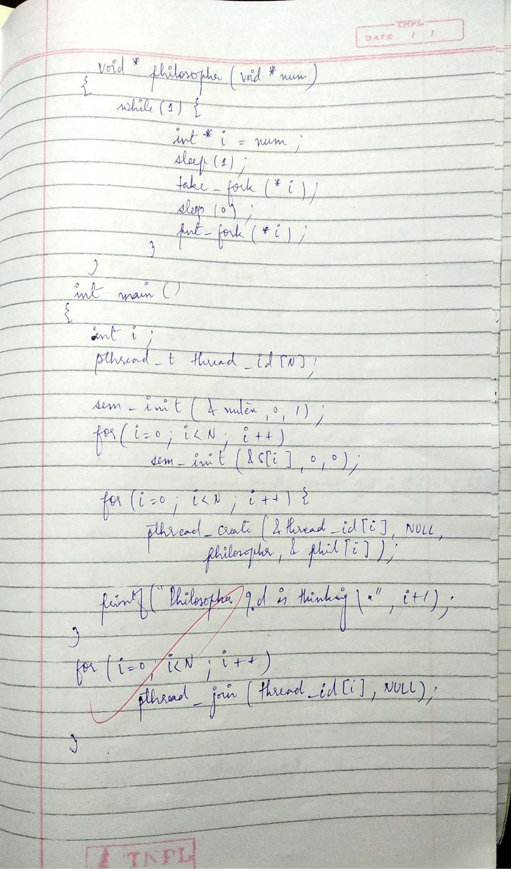

Scanned by CamScanner

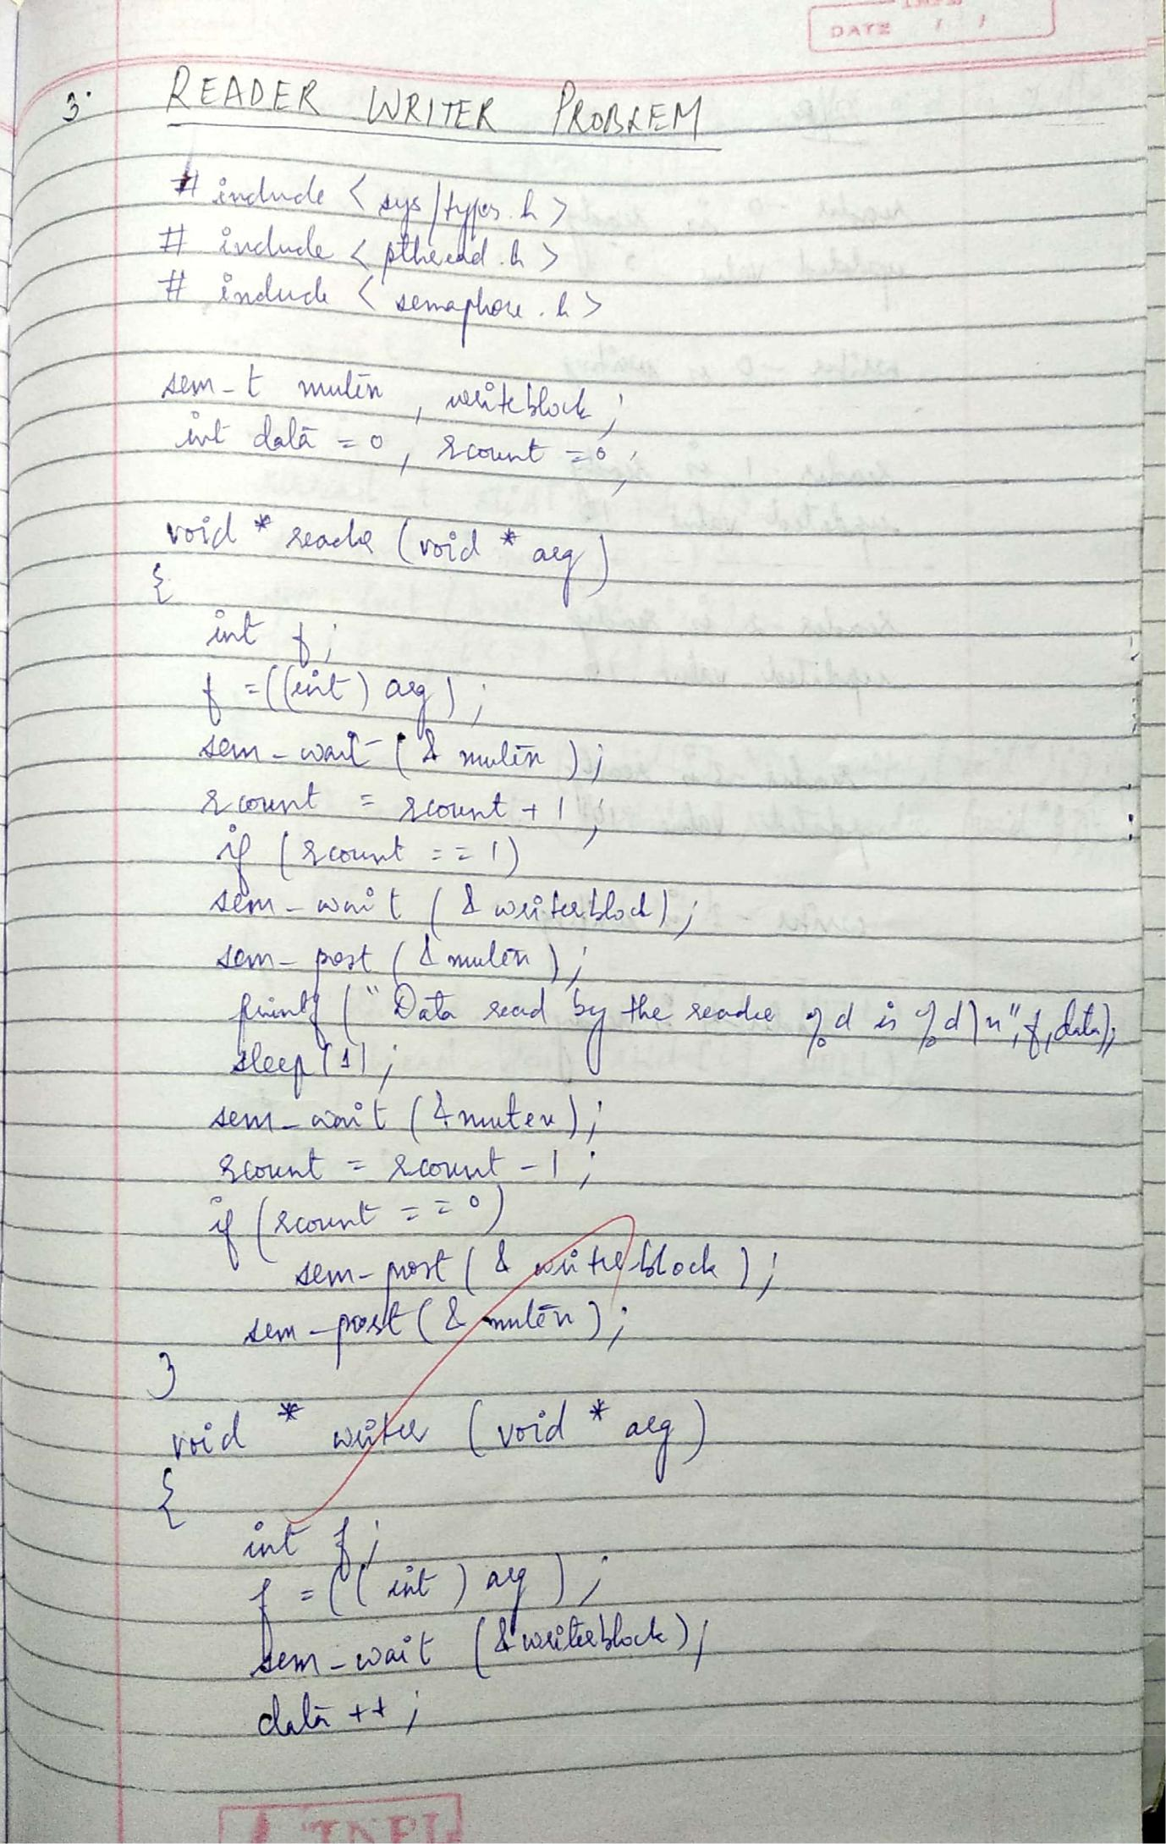

Scanned by CamScanner

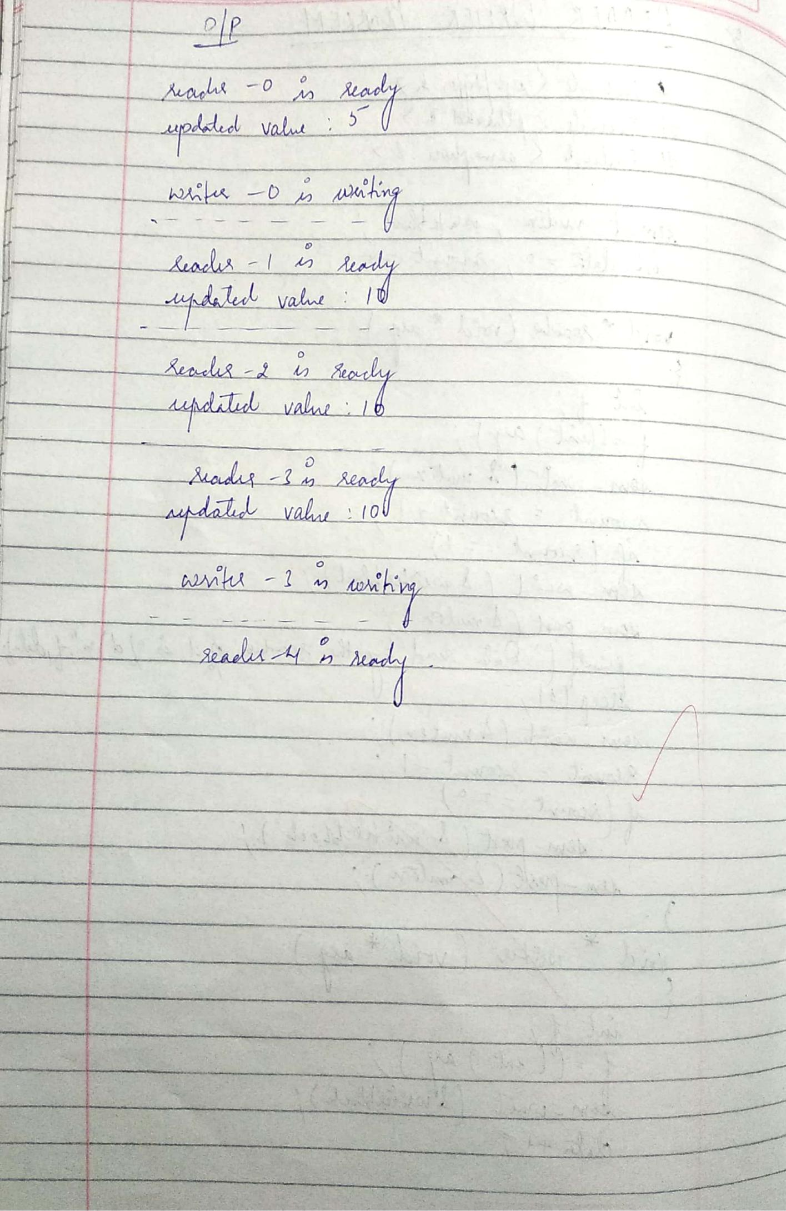

Scanned by CamScanner

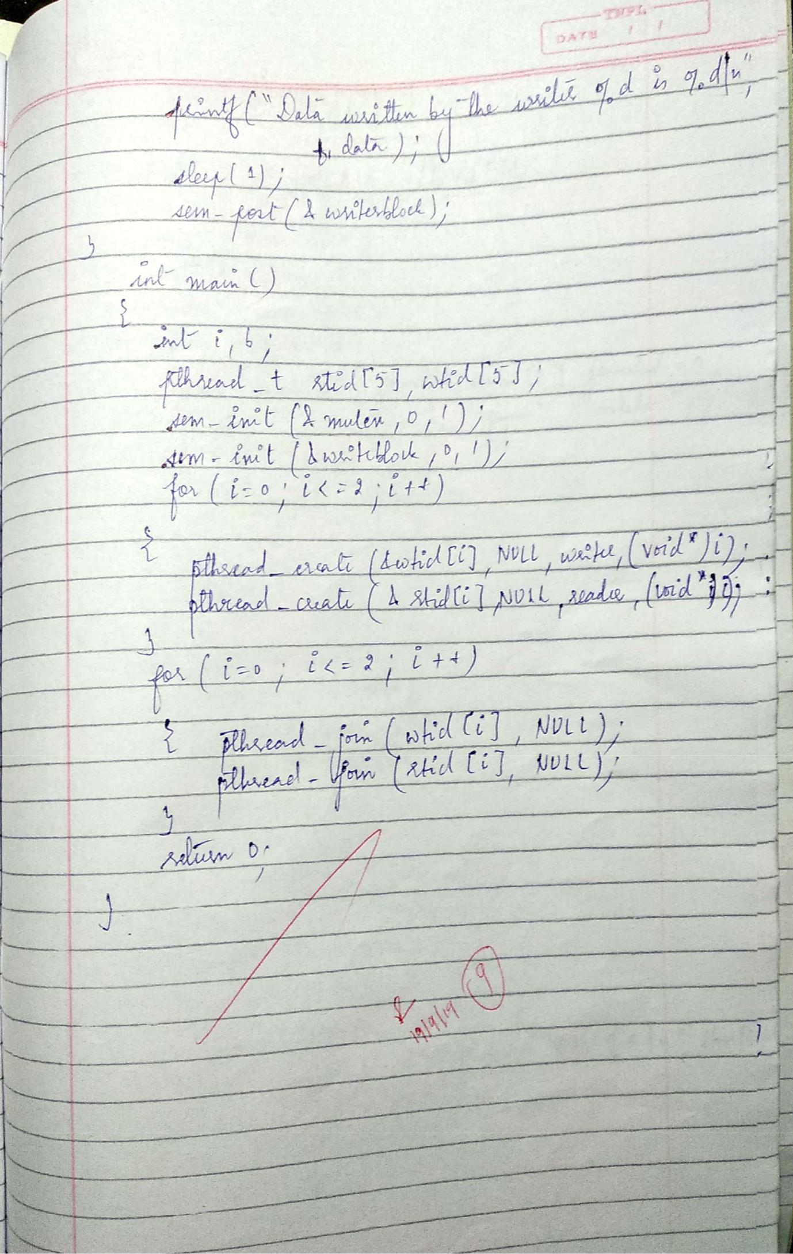

Scanned by CamScanner